Menu Item | Brand

Lunch
Mini Bagel Bites | Tasty Brands
Grilled Cheese Sandwich | Integrated
Baked Crinkle Fries | McCain
Ketchup PPI | Red Gold
Strawberry Cup | Wawona
Grilled Chicken Alfredo | Gold Kist/Dakota Growers/JTM
Garlic Bread Stick | Bake Crafters
Pizza Munchable (Flatbread, Mozzarella Cheese, Pepperoni, Marinara Cup) | Rich’s/Land O Lakes/Jennie O/Red Gold
Glazed Carrots | Inn/Imperial
BBQ Beef Rib Sub | Advance
Potato Smiles | McCain
Bento Box (Cheesestick, Raisins, Benefit Bar, Sunflower Seeds) | Land O Lakes/Sun Maid/J & J Snack Foods/ Zee Zee’s
Applesauce (Blue Raspberry, Watermelon) | Zee Zee’s
Cheese Stuffed Breadsticks | Schwan’s’/Beacon Street
Fiesta Salad (Fajita Chicken, Salsa, Tortilla Chips, Ranch Cup) | Gold Kist/ Red Gold/Snack King/ Naturally Fresh
Ranchero Beans | Bush’s Best
Mesquite Glazed Chicken Drumstick | Tyson
Macaroni and Cheese | JTM
Wheat Roll | Conestoga
Smoked Turkey Cheese Sub  Baked Cheetos | Jennie O/Land O Lake/Aunt Millie/Cheetos
Mustard PPI | Heinz
Mayonnaise PPI | Heinz
Peach Cup | Zee Zee’s
Crispy Chicken Sandwich | Gold Kist
Cheeseburger Sliders | Integrated
Soft Beef Taco with Tortilla Chips and Salsa | Advance/Land O Lakes/Aztec/ Snack King/ Red Gold
Cheeseburger/Hamburger | Integrated/Land O Lakes/Kurz
Big Daddy Pizza (Pepperoni and Cheese) | Big Daddy
Chicken Popper Salad | Gold Kist/Land O Lakes/Pepperidge Farms/Naturally Fresh
Chicken Smackers | Gold Kist
Mashed Potatoes and Gravy | Basic American/Pioneer
Fiestada | Schwan’s/Tony’s
PB & J Uncrustable Sandwich | Smucker’s Uncrustables
Garbanzo Beans | Gordon Food Service
Anytimers Cheese Pizza Lunch Lit | Tasty Brands
Anytimers Turkey and Cheese Lunch Lit | Tasty Brands
Anytimers Turkey Ham and Cheese Lunch Lit | Tasty Brands
White Wheat Sandwich Bread | HEB
Taco Sauce PPI | Flavor Fresh
Yogurt Plate (Yogurt, Granola, Crackers, Applesauce Cup, Fresh Celery Sticks) | Danimals/Tarrier Foods/Kellogg’s/ Zee Zee’s
Nacho Beef Chili Burrito | Cabo Primo/MCI Foods
Mini Corn Dogs | Foster Farms
All Beef Hot Dog on a Bun | Cloverdale Foods/ HEB Buns
Turkey Ham (Substituted meat for Smoked Turkey Cheese Sub)  Red Doritos (Substituted chip for Turkey Cheese Sub meal) | Jennie-O/ Pepsi Co Food Service
Crispy Chicken Drumstick (Substituted drumstick for Mesquite Glazed Chicken Drumstick) | Tyson
Flame Roasted Jalapeno Corn (Grades 9-12) | Simplot
Sweet Potato Waffle Fries | McCain
Yogurt Parfait Plate-Cocoa Cherry Bar | Zee Zee’s
Crispy Chicken Tenders | Tyson
Bosco Sticks | Tyson
Turkey Chili Pie | Jennie-O/ Land O’Lakes/El Sabroso
Turkey Pepperoni Stuffed Sandwich | Schwan’s

Menu Item | Ingredient List
Mini Bagel Bites | 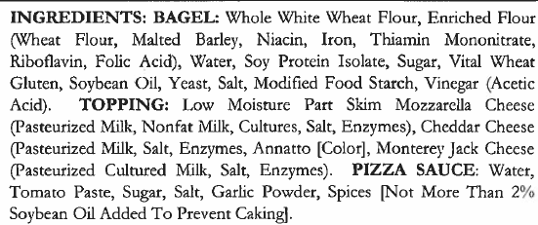
Grilled Cheese Sandwich | 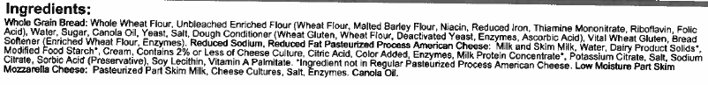
Baked Crinkle Fries | 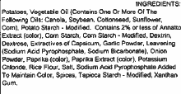
Ketchup PPI | 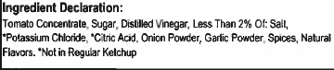
Strawberry Cup | 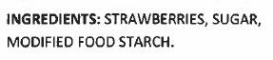
Grilled Chicken Alfredo- Fajita Chicken Strips
Grilled Chicken Alfredo- Alfredo Sauce | 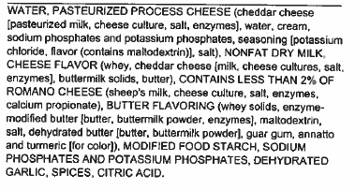
Grilled Chicken Alfredo- Penne Pasta | 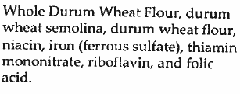
Garlic Bread Stick | 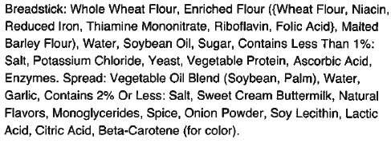
Pizza Munchable –Flatbread | 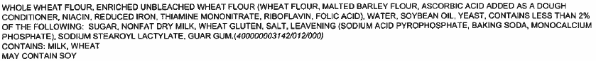
Pizza Munchable –Pepperoni | 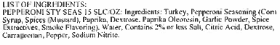
Pizza Munchable –Marinara Cup | 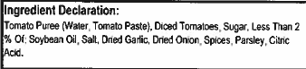
Glazed Carrots
BBQ Beef Rib Sub | 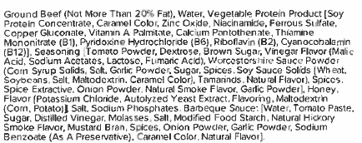
Potato Smiles | 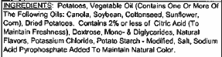
Bento Box- Benefit Bar | 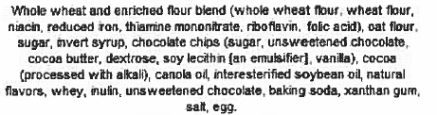
Bento Box- Sunflower Seeds
Bento Box- Raisins (Sour Strawberry) | 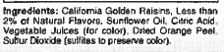
Bento Box- Raisins (Sour Watermelon) | 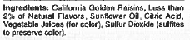
Applesauce Cup (Blue Raspberry)
Applesauce Cup (Watermelon) | 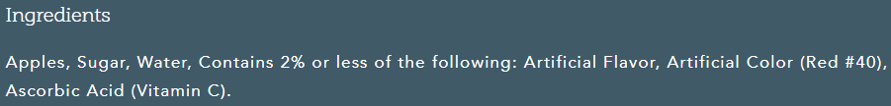
Cheese Stuffed Breadsticks | 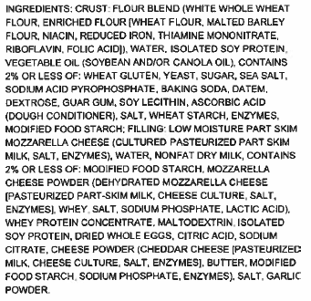
Fiesta Salad- Ranch Cup | 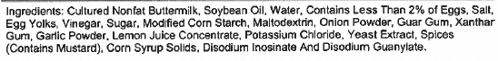
Fiesta Salad- Tortilla Chips | 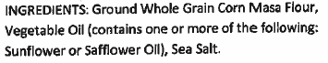
Fiesta Salad -Salsa | 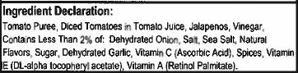
Ranchero Beans | 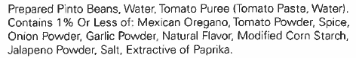
Mesquite Glazed Chicken Drumstick
Macaroni and Cheese | 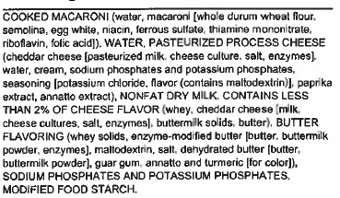
Wheat Roll
Smoked Turkey Cheese Sub- Smoked Turkey | 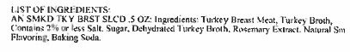
Smoked Turkey Cheese Sub- Sub Bread | 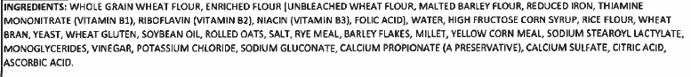
Smoked Turkey Cheese Sub-  Baked Cheetos | 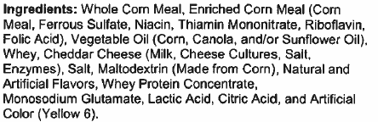
Mustard PPI
Mayonnaise PPI
Peach Cup | 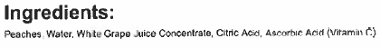
Crispy Chicken Sandwich | 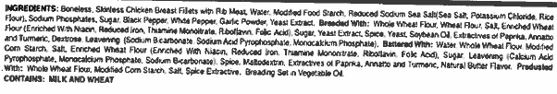
Crispy Chicken Sandwich- Spicy | 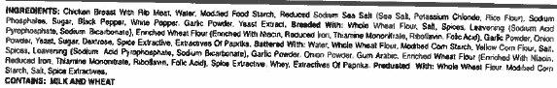
Crispy Chicken Sandwich- Hamburger Bun | 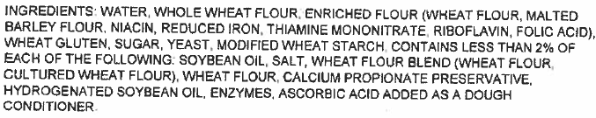
Cheeseburger Sliders | 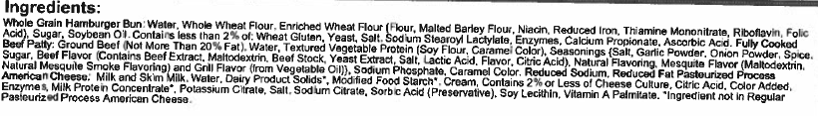
Soft Beef Taco- Beef Taco Filling
Soft Beef Taco- Tortilla | 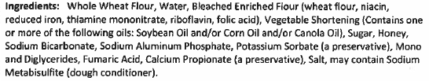
Cheeseburger- Hamburger Patty
Cheeseburger- Sliced Cheese
Big Daddy Pizza- Four Cheese | 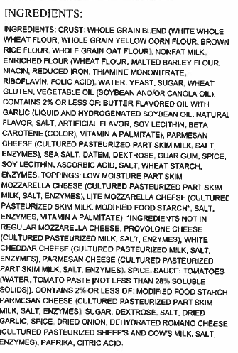
Big Daddy Pizza- Pepperoni | 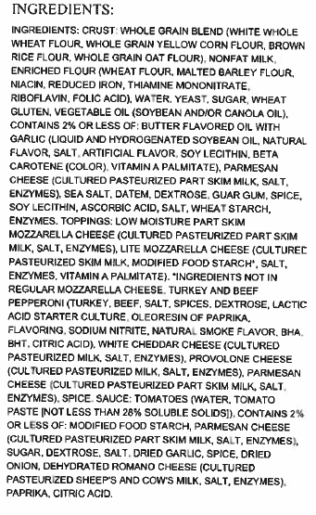
Chicken Popper Salad- Dark Meat Chicken Poppers | 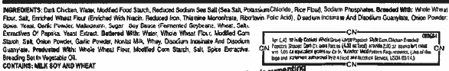
Chicken Popper Salad-Chicken Poppers | 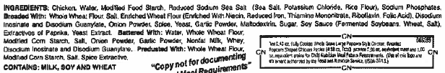
Mashed Potatoes and Gravy- Mashed Potatoes
Mashed Potatoes and Gravy- Gravy
Fiestada | 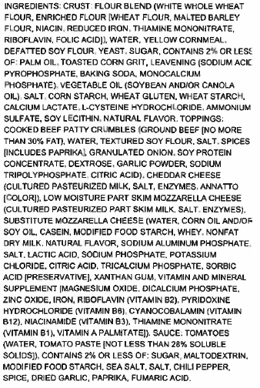
PB & J Uncrustable Sandwich | 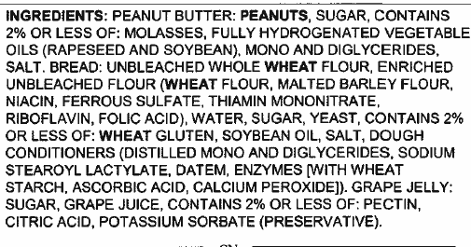
Garbanzo Beans
Anytimers Cheese Pizza Lunch Lit | 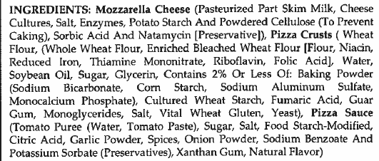
Sandwich Bread
Anytimers Turkey and Cheese Lunch Kit | 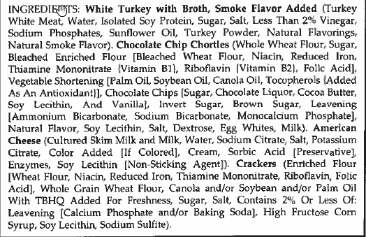
Anytimers Turkey Ham and Cheese Lunch Kit | 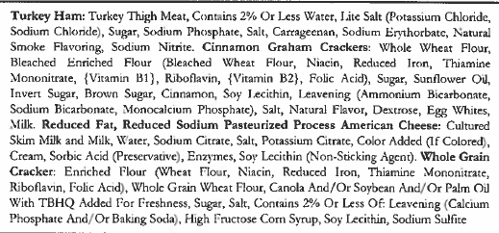
Taco Sauce PPI
Yogurt Plate- Yogurt | 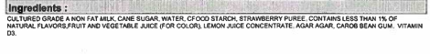
Yogurt Plate- Granola | 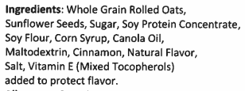
Yogurt Plate- Crackers
Nacho Beef Chili Burrito | 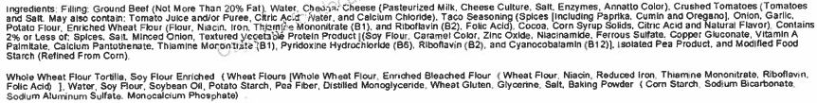
Mini Corn Dogs | 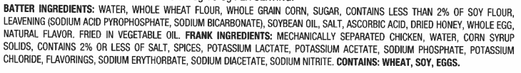
All Beef Hot Dog on a Bun | 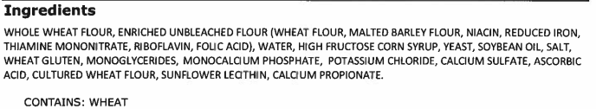  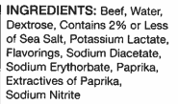
Turkey Ham (Substituted meat for Smoked Turkey Cheese Sub)  Red Doritos (Substituted chip for Turkey Cheese Sub meal) | 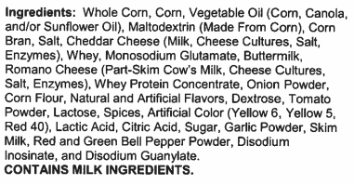  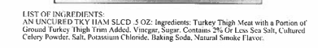
Crispy Chicken Drumstick (Substituted drumstick for Mesquite Glazed Chicken Drumstick) | 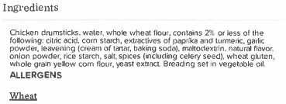
Flame Roasted Jalapeno Corn | 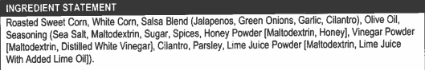
Sweet Potato Waffle Fries | 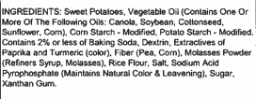
Yogurt Parfait Plate-  Cocoa Cherry Bar | 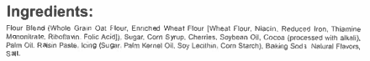
Crispy Chicken Tenders | 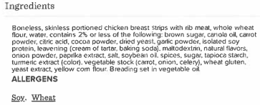
Bosco Sticks | 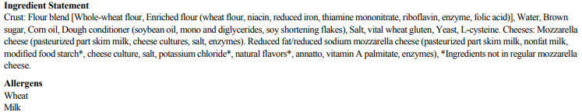
Turkey Chili Pie- Chili | 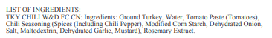
Turkey Chili Pie- Cheese

Turkey Chili Pie- Chips | 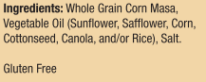
Turkey Pepperoni Stuffed Sandwich | 