Menu Item | Brand

Breakfast
Mini Sausage Bagel | Integrated
Lucky Charms Cereal | General Mills
Cocoa Puffs Cereal | General Mills
Applesauce (Blue Raspberry, Watermelon) | Zee Zee’s
Chicken and Maple Waffle | Tyson/Bake Crafters
Whole Grain Donut Stick | Sky Blue
Sausage Cheese Biscuit | Jennie O/Conestoga
Cinnamon Glazed French Toast Slice | Pappetti’s
Pancake on a Stick | Foster Farms
Mini Cinnamon Waffle Bites | Kellogg’s
Whole Grain Pop Tart (Frosted Blueberry, Frosted Strawberry) | Kellogg’s
Turkey Sausage Patty | Jennie O
Chicken Biscuit Sandwich | Tyson/Conestoga
Mini Confetti Pancakes | Pillsbury
Banana Bread | Super Bakery
Breakfast Bun | Sky Blue
Mini Blueberry Muffins | Dave’s Baking Company
Syrup Cup | Gordon’s Choice
Veggie Breakfast Sausage Patty (Substituted patty for Sausage Cheese Biscuit, Muffin and Sausage, Mini Pancakes and Sausage) | Morning Star Farms/ Kellogg’s
Buttery Maple Waffle (Substituted waffle for Chicken and Maple Waffle) | Arlington Valley Farms Snack’n Waffles
Sausage, Egg, and Cheese Tornado | Ruiz Foods
Blueberry Chex Cereal- Gluten Free (Substituted cereal for Lucky charms- Gluten Free) | General Mills
Taco Sauce PPI | GFS

Menu Item | Ingredient List
Mini Sausage Bagel | 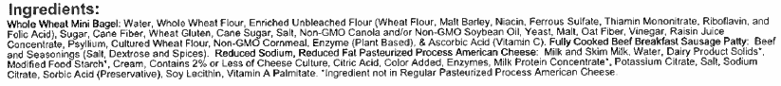
Lucky Charms Cereal
Cocoa Puffs Cereal
Applesauce (Watermelon) | 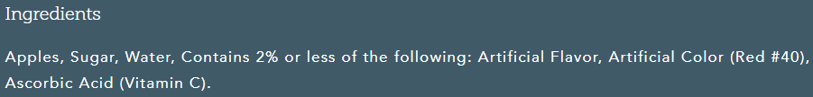
Applesauce (Blue Raspberry)
Chicken and Maple Waffle- Chicken Patty | 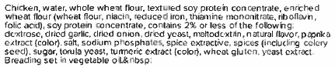
Chicken and Maple Waffle- Waffle | 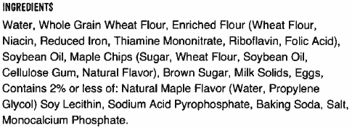
Whole Grain Donut Stick | 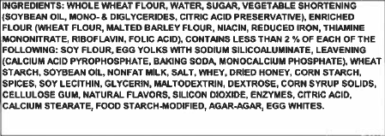
Sausage Cheese Biscuit- Sausage Patty | 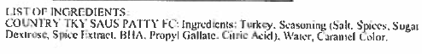
Sausage Cheese Biscuit- Biscuit | 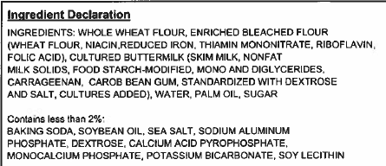
Cinnamon Glazed French Toast Slice | 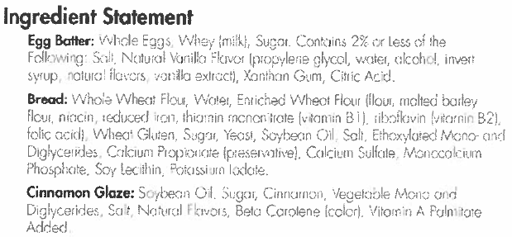
Maple Pancake on a Stick | 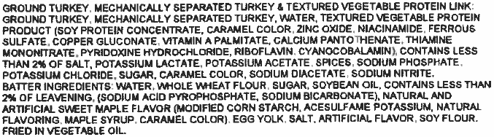
Mini Cinnamon Waffle Bites
Whole Grain Pop Tart (Frosted Strawberry) | Frosted Strawberry  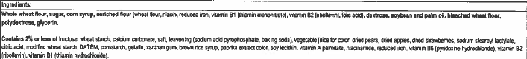
Whole Grain Pop Tart (Frosted Blueberry) | 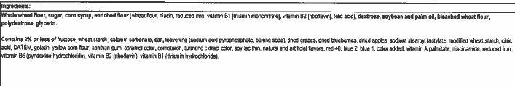
Turkey Sausage Patty
Chicken Biscuit Sandwich- Chicken Patty
Chicken Biscuit Sandwich- Biscuit
Mini Confetti Pancakes
Banana Bread | 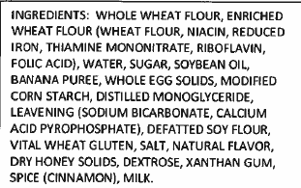
Breakfast Bun | 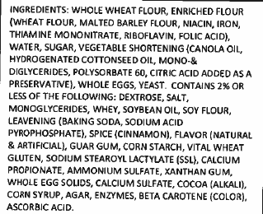
Mini Blueberry Muffins | 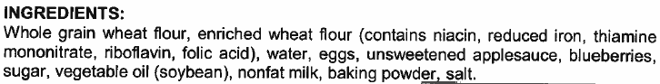
Syrup Cup | 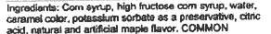
Veggie Breakfast Sausage Patty (Substituted patty for Sausage Cheese Biscuit, Muffin and Sausage, Mini Pancakes and Sausage) | 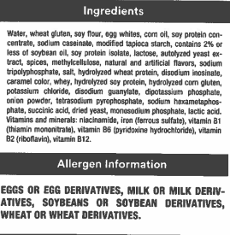
Buttery Maple Waffle (Substituted waffle for Chicken and Maple Waffle) | 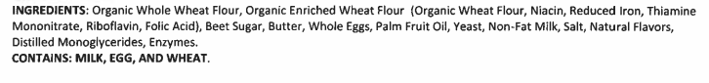
Sausage, Egg, and Cheese Tornado | 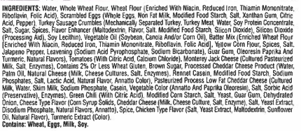
Blueberry Chex Cereal- Gluten Free (Substituted cereal for Lucky charms- Gluten Free) | 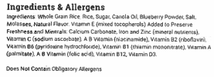
Taco Sauce | 