 | Menu Item |  | Brand
 | Lunch
 | Mini Bagel Bites |  | Tasty Brands
 | Grilled Cheese Sandwich |  | Integrated
 | Baked Crinkle Fries |  | McCain
 | Ketchup PPI |  | Red Gold
 | Strawberry Cup |  | Wawona
 | Grilled Chicken Alfredo |  | Gold Kist/Dakota Growers/JTM
 | Garlic Bread Stick |  | Bake Crafters
 | Pizza Munchable (Flatbread, Mozzarella Cheese, Pepperoni, Marinara Cup) |  | Rich’s/Land O Lakes/Jennie O/Red Gold
 | Glazed Carrots |  | Inn/Imperial
 | BBQ Beef Rib Sub |  | Advance
 | Potato Smiles |  | McCain
 | Bento Box (Cheesestick, Raisins, Benefit Bar, Sunflower Seeds) |  | Land O Lakes/Sun Maid/J & J Snack Foods/ Zee Zee’s
 | Applesauce (Blue Raspberry, Watermelon) |  | Zee Zee’s
 | Cheese Stuffed Breadsticks |  | Schwan’s’/Beacon Street
 | Fiesta Salad (Fajita Chicken, Salsa, Tortilla Chips, Ranch Cup) |  | Gold Kist/ Red Gold/Snack King/ Naturally Fresh
 | Ranchero Beans |  | Bush’s Best
 | Mesquite Glazed Chicken Drumstick |  | Tyson
 | Macaroni and Cheese |  | JTM
 | Wheat Roll |  | Conestoga
 | Smoked Turkey Cheese Sub  Baked Cheetos |  | Jennie O/Land O Lake/Aunt Millie/Cheetos
 | Mustard PPI |  | Heinz
 | Mayonnaise PPI |  | Heinz
 | Peach Cup |  | Zee Zee’s
 | Crispy Chicken Sandwich |  | Gold Kist
 | Cheeseburger Sliders |  | Integrated
 | Soft Beef Taco with Tortilla Chips and Salsa |  | Advance/Land O Lakes/Aztec/ Snack King/ Red Gold
 | Cheeseburger/Hamburger |  | Integrated/Land O Lakes/Kurz
 | Big Daddy Pizza (Pepperoni and Cheese) |  | Big Daddy
 | Chicken Popper Salad |  | Gold Kist/Land O Lakes/Pepperidge Farms/Naturally Fresh
 | Chicken Smackers |  | Gold Kist
 | Mashed Potatoes and Gravy |  | Basic American/Pioneer
 | Fiestada |  | Schwan’s/Tony’s
 | PB & J Uncrustable Sandwich |  | Smucker’s Uncrustables
 | Garbanzo Beans |  | Gordon Food Service
 | Anytimers Cheese Pizza Lunch Lit |  | Tasty Brands
 | Anytimers Turkey and Cheese Lunch Lit |  | Tasty Brands
 | Anytimers Turkey Ham and Cheese Lunch Lit |  | Tasty Brands
 | White Wheat Sandwich Bread |  | HEB
 | Taco Sauce PPI |  | Flavor Fresh
 | Yogurt Plate (Yogurt, Granola, Crackers, Applesauce Cup, Fresh Celery Sticks) |  | Danimals/Tarrier Foods/Kellogg’s/ Zee Zee’s
Menu Item |  | Ingredient List
Mini Bagel Bites |  | 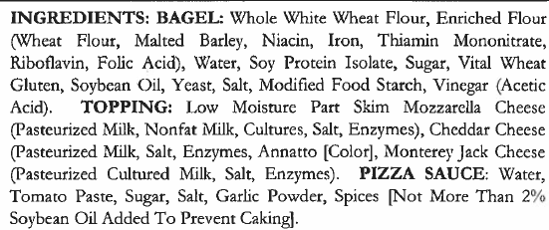
Grilled Cheese Sandwich |  | 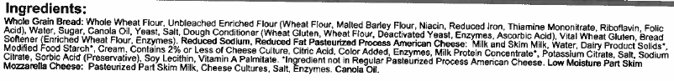
Baked Crinkle Fries |  | 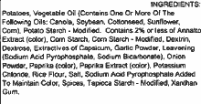
Ketchup PPI |  | 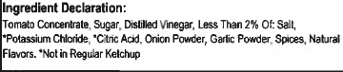
Strawberry Cup |  | 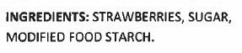
Grilled Chicken Alfredo- Fajita Chicken Strips
Grilled Chicken Alfredo- Alfredo Sauce |  | 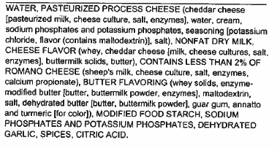
Grilled Chicken Alfredo- Penne Pasta |  | 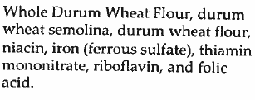
Garlic Bread Stick |  | 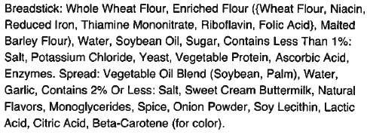
Pizza Munchable –Flatbread |  | 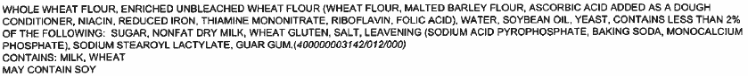
Pizza Munchable –Pepperoni |  | 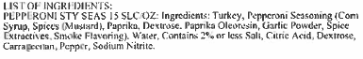
Pizza Munchable –Marinara Cup |  | 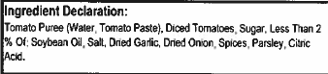
Glazed Carrots
BBQ Beef Rib Sub |  | 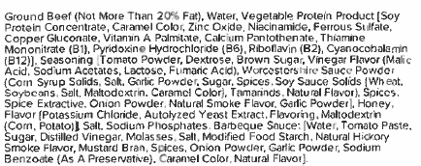
Potato Smiles |  | 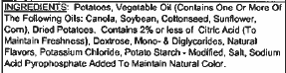
Bento Box- Benefit Bar |  | 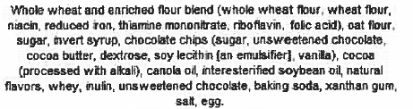
Bento Box- Sunflower Seeds
Bento Box- Raisins (Sour Strawberry) |  | 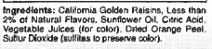
Bento Box- Raisins (Sour Watermelon) |  | 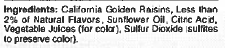
Applesauce Cup (Blue Raspberry)
Applesauce Cup (Watermelon) |  | 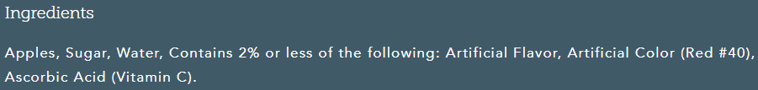
Cheese Stuffed Breadsticks |  | 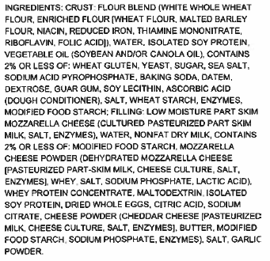
Fiesta Salad- Ranch Cup |  | 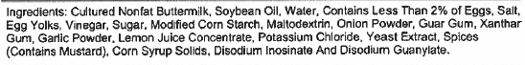
Fiesta Salad- Tortilla Chips |  | 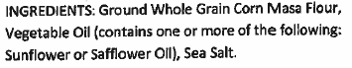
Fiesta Salad -Salsa |  | 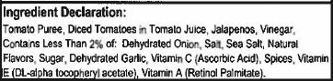
Ranchero Beans |  | 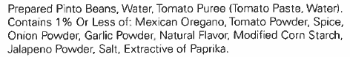
Mesquite Glazed Chicken Drumstick
Macaroni and Cheese |  | 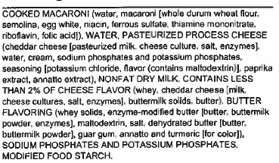
Wheat Roll
Smoked Turkey Cheese Sub- Smoked Turkey |  | 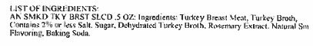
Smoked Turkey Cheese Sub- Sub Bread |  | 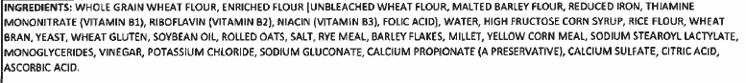
Smoked Turkey Cheese Sub-  Baked Cheetos |  | 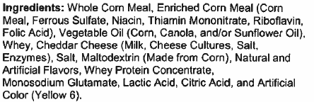
Mustard PPI
Mayonnaise PPI
Peach Cup |  | 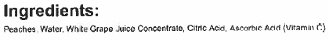
Crispy Chicken Sandwich |  | 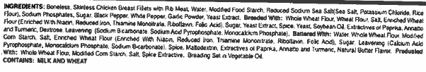
Crispy Chicken Sandwich- Spicy |  | 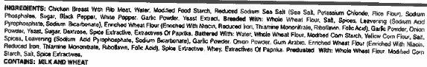
Crispy Chicken Sandwich- Hamburger Bun |  | 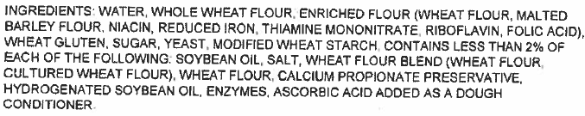
Cheeseburger Sliders |  | 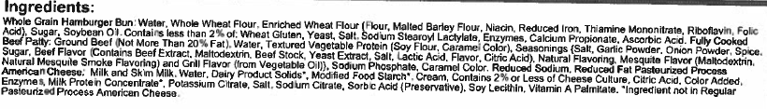
Soft Beef Taco- Beef Taco Filling
Soft Beef Taco- Tortilla |  | 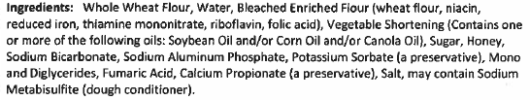
Cheeseburger- Hamburger Patty
Cheeseburger- Sliced Cheese
Big Daddy Pizza- Four Cheese |  | 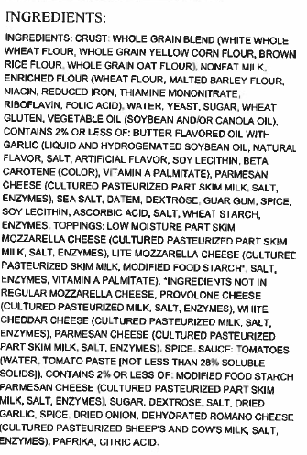
Big Daddy Pizza- Pepperoni |  | 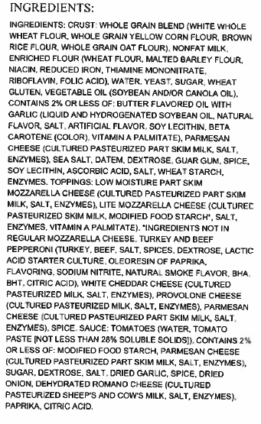
Chicken Popper Salad- Dark Meat Chicken Poppers |  | 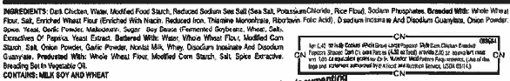
Chicken Popper Salad-Chicken Poppers |  | 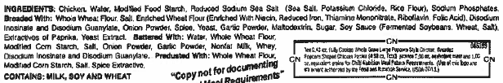
Mashed Potatoes and Gravy- Mashed Potatoes
Mashed Potatoes and Gravy- Gravy
Fiestada |  | 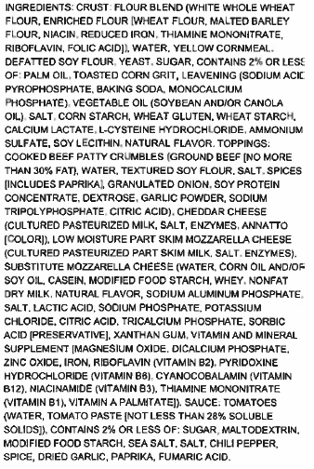
PB & J Uncrustable Sandwich |  | 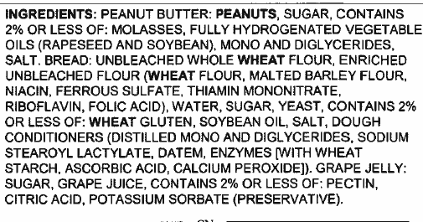
Garbanzo Beans
Anytimers Cheese Pizza Lunch Lit |  | 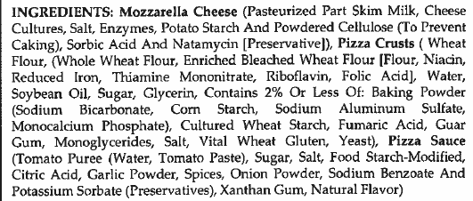
Sandwich Bread
Anytimers Turkey and Cheese Lunch Kit |  | 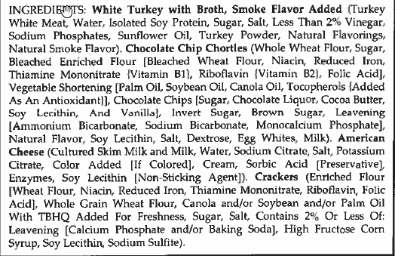
Anytimers Turkey Ham and Cheese Lunch Kit |  | 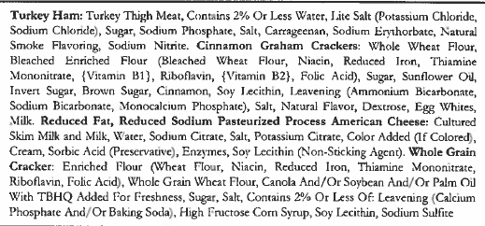
Taco Sauce PPI
Yogurt Plate- Yogurt |  | 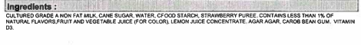
Yogurt Plate- Granola |  | 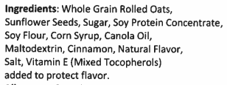
Yogurt Plate- Crackers

