Menu Item | Brand

ASCP
Mini Blueberry Muffin | Dave’s Baking Company
Goldfish Crackers | Pepperidge Farms
Vanilla Grahams | Pepperidge Farms
Dannon Yogurt | Dannon
Cheez-It Crackers | Kellogg’s
Chocolate Chip Cookie | Cookie Tree

Ala Carte
Marinara Dunk Cup | Red Gold
Fruit Roll Up | Betty Crocker
Cookie | Cookie Tree
Rice Krsipy Treat | Kellogg’s
Brownie | Buena Vista
Cry Baby | Rosati
Munchies | Frito Lay/Pepsi
Flamin’ Hot Cheetos | Frito Lay/Pepsi
Flamin’ Fantastix | Frito Lay/Pepsi
Doritos Cool Ranch Doritos | Frito Lay/Pepsi
Doritos Flamas Tortilla Chips | Frito Lay/Pepsi
Doritos Spicy Sweet Chili Tortilla Chips | Frito Lay/Pepsi
Doritos Nacho Cheese Tortilla Chips | Frito Lay/Pepsi
Chicken Tenders (2) w/ BBQ Sauce | Pilgrim’s Pride
Kettle Corn Popcorn | Tasty Brands
Hershey’s Milk | Hershey’s
Bosco Stick | Tyson Bosco’s
Corn Dog | Foster Farms
Mozzarella Cheese Sticks (5) | Tasty Brands
Tornado | Tornado’s
Gatorade | Pepsi Company
Switch | Switch
Snapple | Snapple
Propel Water | Pepsi Company
Pizza Slice | Dominos
Cold Brew Iced Coffee | Dannon Stok
Spicy Crab Sushi Roll | Moji
California Sushi Roll | Moji

Menu Item | Ingredient List
Marinara Dunk Cup | 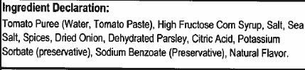
Mini Blueberry Muffin | 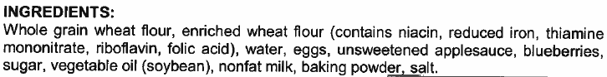
Goldfish Crackers | 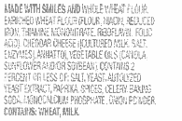
Vanilla Grahams | 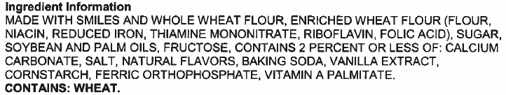
Dannon Yogurt (Strawberry)
Cheez-It Crackers
Chocolate Chip Cookie | 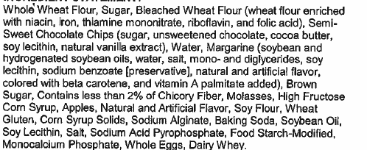
Fruit Roll Up- Blastin’ Berry
Cookie- Chocolate Chip | 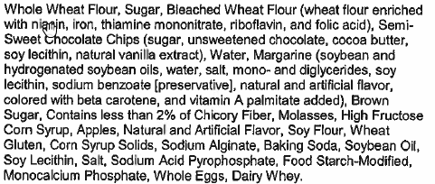
Rice Krsipy Treat
Brownie
Cry Baby | 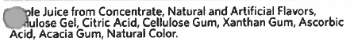
Munchie’s Mix | 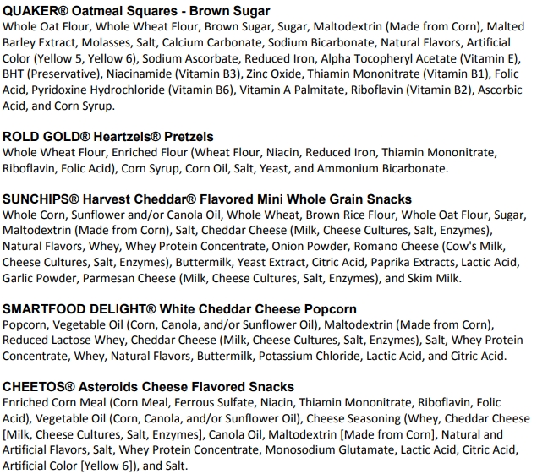
Flamin’ Hot Cheetos
Flamin’ Fantastix | 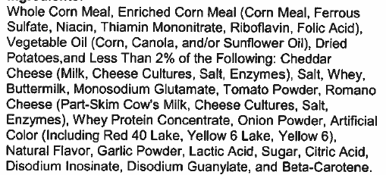
Doritos Cool Ranch Doritos | 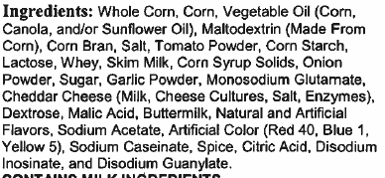
Doritos Flamas Tortilla Chips | 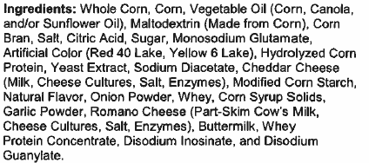
Doritos Spicy Sweet Chili Tortilla Chips | 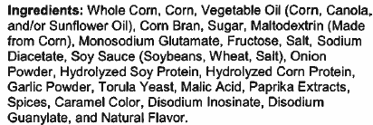
Doritos Nacho Cheese Tortilla Chips | 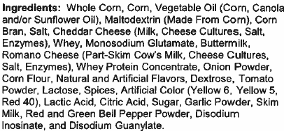
Chicken Tenders | 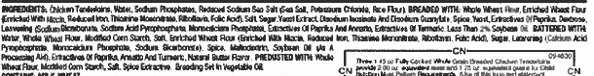
BBQ Sauce | 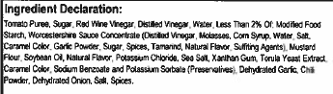
Kettle Corn Popcorn
Hershey’s Milk | 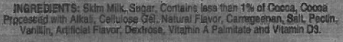
Bosco Stick | 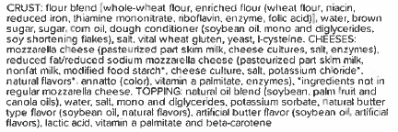
Corn Dog | 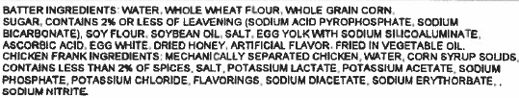
Mozzarella Cheese Sticks (5) | 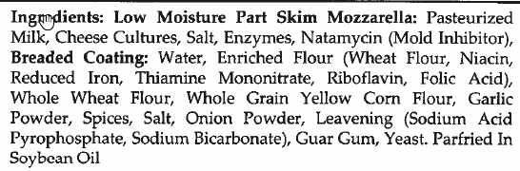
Tornado | 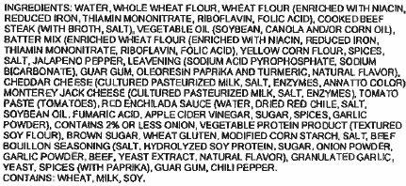
G2- Fruit Punch | 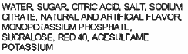
G2- Orange | 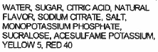
G2- Grape | 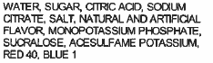
Gatorade Zero- Glacier Freeze | 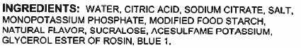
Gatorade Zero- Glacier Cherry | 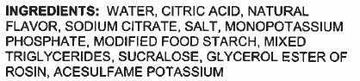
Gatorade Zero- Thirst Quencher | 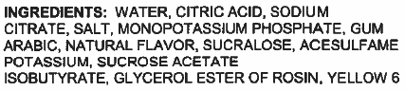
Gatorade Zero- Fruit Punch | 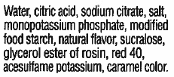
Switch- Fruit Punch | 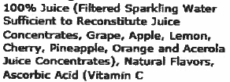
Switch- Grape | 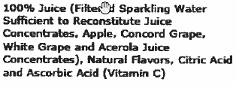
Switch- Kiwi Berry | 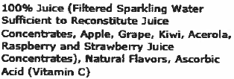
Switch- Watermelon Strawberry | 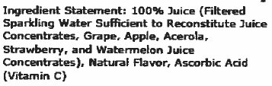
Snapple- Grape | 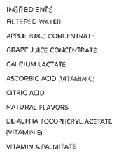
Snapple- Green Apple | 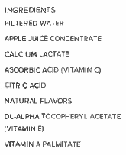
Snapple- Fruit Punch | 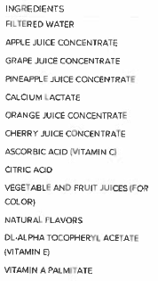
Propel- Watermelon | 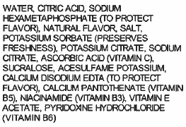
Propel- Grape | 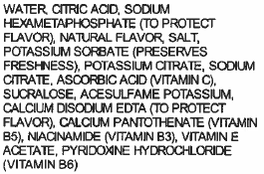
Propel- Kiwi Strawberry | 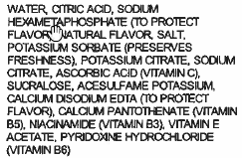
Pizza Slice- Cheese | 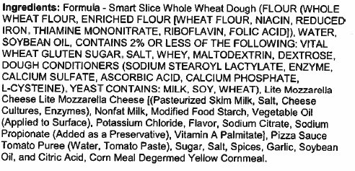
Pizza Slice- Pepperoni | 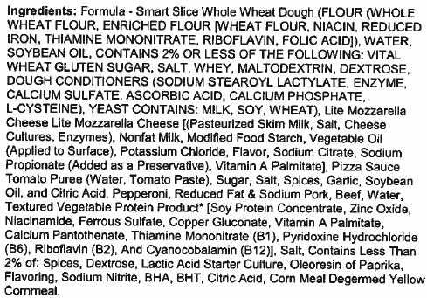
Cold Brew Iced Coffee | 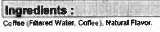
Spicy Crab Sushi Roll | 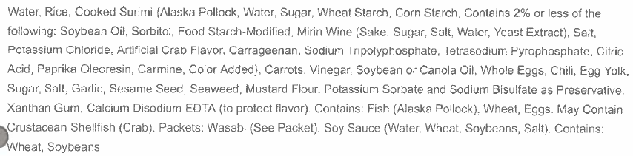
California Sushi Roll | 