K-8 Ala Carte Ingredient Lists with Allergens

Dominos Cheese Pizza- Ala Carte Only- $2.25

Allergens: Milk, Soy, and Wheat
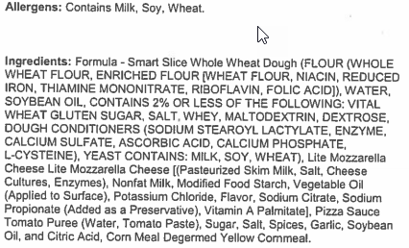

Dominos Pork and Beef Pepperoni Pizza- Ala Carte Only- $2.25

Allergens: Milk, Soy, and Wheat
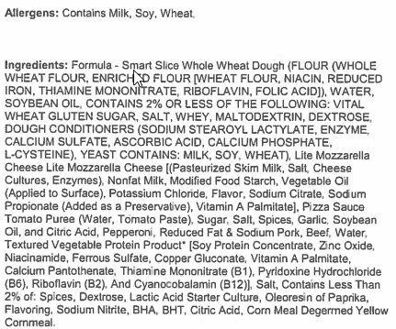

Tuscan Cheese Pizza- Ala Carte Only- $2.25

Allergens: Milk, Soy, and Wheat
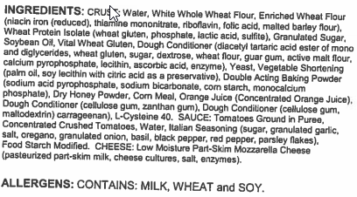

Welch’s Slush- Grape
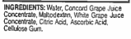

Brownie

Allergens: Egg, Milk, Soy, and Wheat

Baked Cheetos

Allergens: Milk
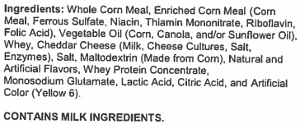

Baked Cheetos- Flamin’ Hot

Allergens: Milk
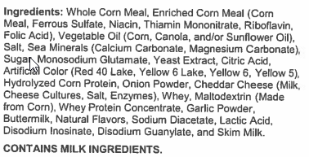

Reduced Fat Doritos- Flamas

Allergens: Milk
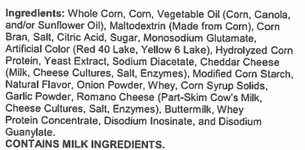

Reduced Fat Doritos- Cool Ranch

Allergens: Milk
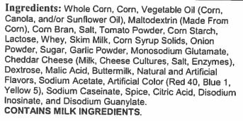

Reduced Fat Doritos- Nacho Cheese

Allergens: Milk
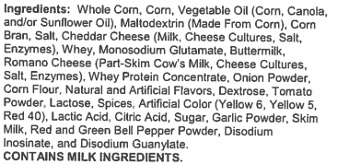

Reduced Fat Doritos- Spicy Sweet Chili

Allergens: Wheat and Soy
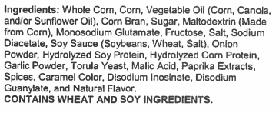

Fantastix Corn & Potato Crisps- Flamin’ Hot

Allergens: Milk
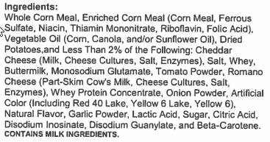

Fantastix Corn & Potato Crisps- Chili Cheese

Allergens: Milk

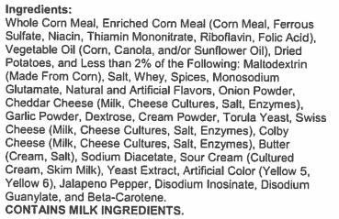

Baked Funyuns

Allergens: Milk
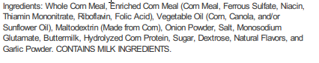

Baked Lay’s- Original Potato Crisps

Allergens: Soy
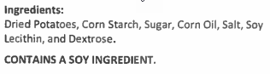

Baked Lay’s- Sour Cream & Onion Potato Crisps

Allergens: Milk and Soy
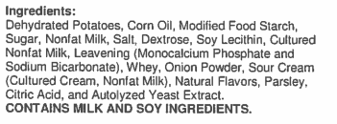

Rosati Cry Baby- Sour Cherry
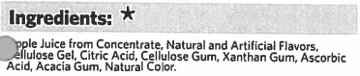
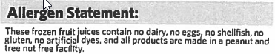

Fruit Roll Up- Blastin’ Berry Hot Colors

Cookie- Chocolate Chip

Allergens: Wheat, Eggs, Dairy, and Soy
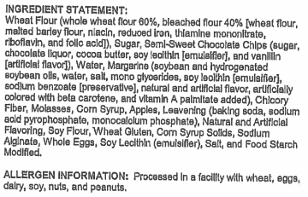

Cookie- Sugar

Allergens: Eggs, Milk, Soy Beans and Wheat
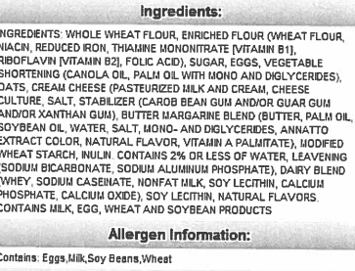

Cookie- Candy

Allergens: Eggs, Milk, Soy Beans, and Wheat
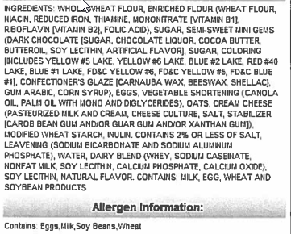

Ice Cream- Chocolate and Vanilla Cup

Allergens: Milk
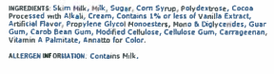

Ice Cream- Vanilla Fudge Swirl Cone

Allergens: Milk, Soy, and Wheat
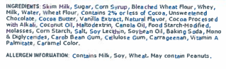

Ice Cream- Cookies and Cream Cone

Allergens: Milk, Soy, and Wheat
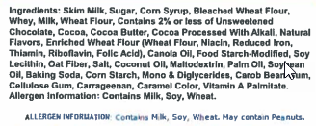

Ice Cream- Chocolate Sundae Crunch Bar

Allergens: Milk, Soy, and Wheat
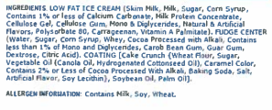

Ice Cream- Strawberry Sundae Crunch Bar

Allergens: Milk, Soy, and Wheat
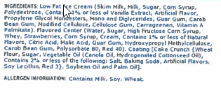

Ice Cream- Vanilla Ice Cream Sandwich

Allergens: Milk, Soy, and Wheat
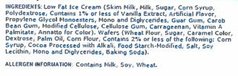

Ice Cream- Classic Fudge Bar

Allergens: Milk

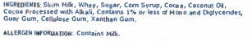

Ice Cream- Classic Orange Dream Bar

Allergens: Milk
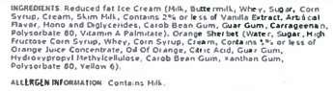

Ice Cream- Banana Fudge Bomb Pop Jr.

Allergens: Milk
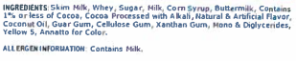

Ice Cream- Strawberry Banana Fruit Bomb Pop Jr.

Allergens: Milk
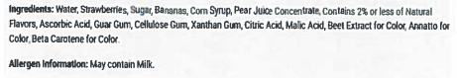

Ice Cream- Strawberry Raspberry Fruit Bomb Pop Jr.

Allergens: Milk
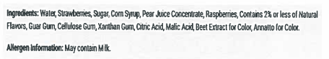

Ice Cream- FrozFruit Chunky Strawberry
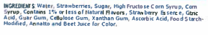

Ice Cream- FrozFruit Chunky Pineapple
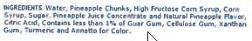

9-12 Ala Carte Ingredient Lists with Allergens

Smucker’s Uncrustable- Grape

Allergens: Peanuts and Wheat
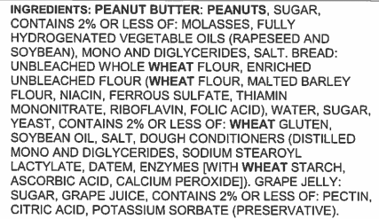

Propel- Watermelon
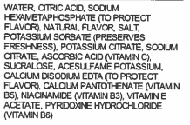

Propel- Strawberry Kiwi
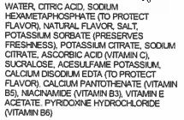

G2- Clear Mixed Berry
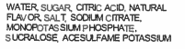

G2- Fruit Punch
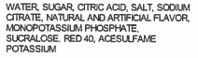

G2- Glacier Freeze
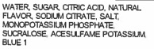

G2- Orange
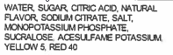

G2- Grape
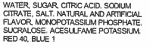

Gatorade Zero- Glacier Cherry
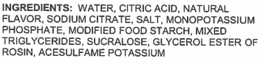

Gatorade Zero- Glacier Freeze
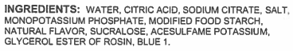

Switch- Grape
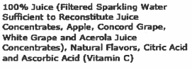

Switch- Fruit Punch
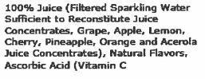

Switch- Kiwi Berry
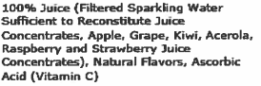

Switch- Lemon Lime
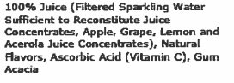

Switch- Watermelon Strawberry
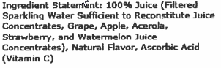

Switch- Black Cherry
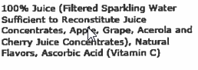

Switch- Orange Tangerine
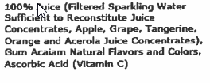

Switch- Hardcore Apple
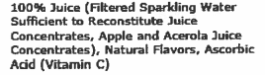

Switch- Tropical Pineapple
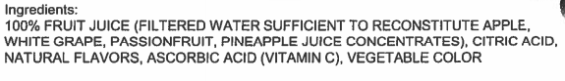

Snapple- Fruit Punch
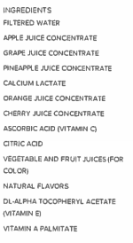

Snapple- Green Apple
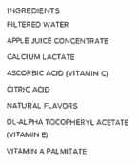

Red Diamond Tea- Sugar Free w/Splenda

JB’s Tea- Decaf Mango Peach

JB’s Tea- Decaf Lemon

Chicken Bites

Allergens: Milk and Wheat
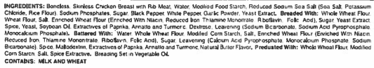

Ranchero Beef Steak & Cheese Tornado

Allergens: Wheat, Soy, and Milk
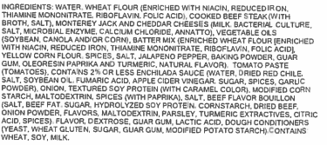

Chicken Egg Roll

Allergens: Milk, Eggs, Wheat, and Soy
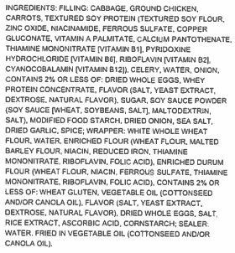

Sweet & Sour Sauce Packet
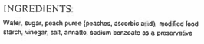

Chicken Corn Dog

Allergens: Wheat, Soy, eggs, and Gluten
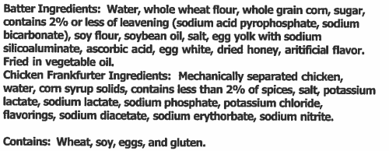

Yellow Mustard Packet
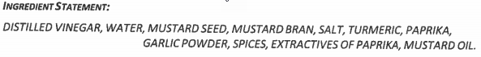

Deep Groove Crinkle Fries
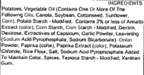

Tomato Ketchup Packet
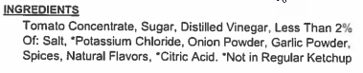

Tater Tots
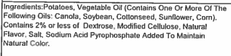

Hashbrown Rounds
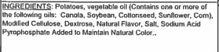

Bosco Cheese Breadstick

Allergens: Milk and Wheat
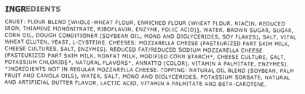

Hershey’s Fat Free Chocolate Milk

Allergens: Milk
Skim Milk, Sugar, Contains Less Than 1% Of Cocoa, Cocoa Processed With Alkali, Cellulose Gel, Natural Flavor, Carrageenan, Salt, Pectin, Vanillin, Artificial Flavor, Dextrose, Vitamin A Palmitate And Vitamin D3.

Whole Grain Brownie

Allergens: Wheat, Milk, Egg, and Soy
