K-12 Breakfast Ingredient Lists with Allergens

Sausage Cheese Biscuit
(Turkey Sausage Patty and Cheese Slice on a Biscuit)

Turkey Sausage Patty
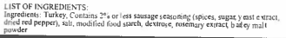

Biscuit

Allergens: Wheat, Milk, and Soy
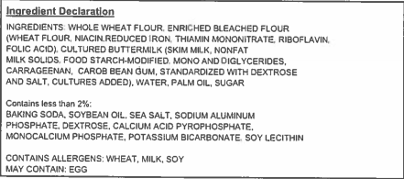

Mini Confetti Pancakes and Sausage Patty
(Mini Confetti Pancakes and Turkey Sausage Patty)

Mini Confetti Pancakes

Allergens: Wheat, Milk, Egg, and Soy

Turkey Sausage Patty

Pancake on a Stick
(Turkey Sausage Wrapped in a Maple Flavored Pancake)

Allergens: Wheat, Soy, Milk, and Eggs

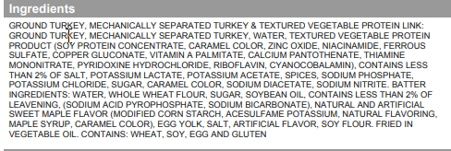

Chicken Biscuit
(Breaded Chicken Patty on a Biscuit)

Chicken Breakfast Patty

Allergens: Soy and Wheat
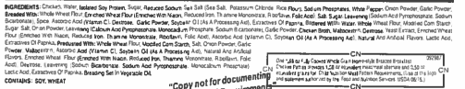

Biscuit

Allergens: Wheat, Milk, and Soy

Donut Stick
(Honey Wheat Breakfast Bar)

Allergens: Wheat, Soy, Milk, and Eggs
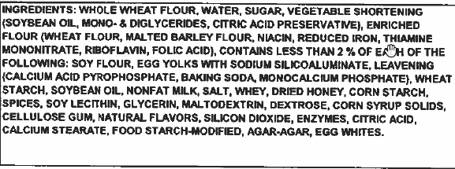

Sunrise Stick
(Chorizo Seasoned Beef and Cheese Sunrise Stick)

Allergens: Wheat, Milk, and Soy
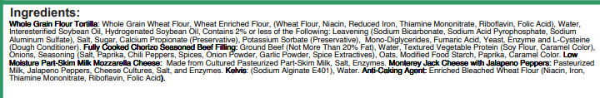

French Toast Sticks
(Cinnamon Glazed French Toast Sticks)

Allergens: Egg, Milk, Soybean, and Wheat
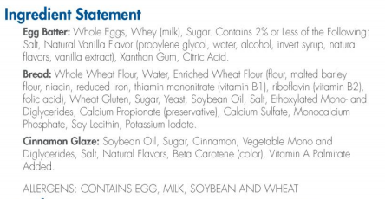

Sausage Gravy Pizza
(Turkey Breakfast Sausage and Mozzarella Cheese with Turkey Sausage Gravy on a Whole Grain Crust)
Allergens: Milk, Wheat, and Soy
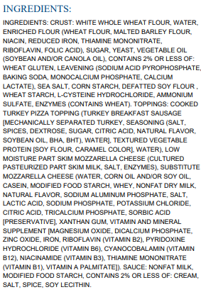

Banana Bread and Sausage Patty
(Banana Bread and Sausage Patty)

Banana Bread
Allergens: Egg, Milk, Wheat, and Soy

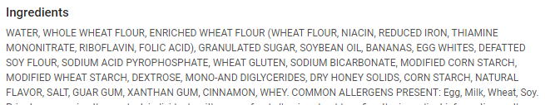

Turkey Sausage Patty

Kolache
(Pork, Chicken, Beef, and Cheese Knockwurst Sausage Baked in Dough)
Allergens: Egg, Milk, Wheat, and Soy
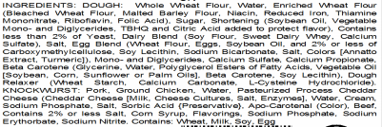

Waffle Bites
(Kellogg’s Cinnamon Mini Waffle Bites)
Allergens: Egg, Milk, Wheat, and Soy
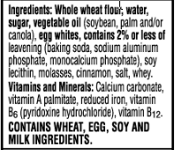

BeneFIT Bar - Cocoa Chip

Allergens: Eggs, Milk, Soy Beans, and Wheat
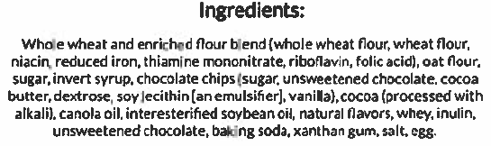

BeneFIT Bar – French Toast

Allergens: Eggs, Milk, Soy Beans, and Wheat
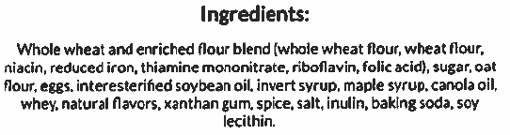

Gluten Free Cinnamon Chex Cereal
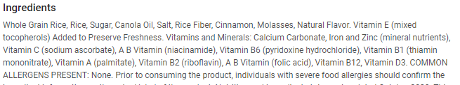

Lucky Charms Cereal
