K-12 Lunch Ingredient Lists with Allergens

Mini Corn Dogs
(Mini Honey Crunchy Wrapped Turkey Franks)
Allergens: Wheat, Soy, Eggs, and Gluten
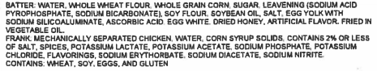

Soft Beef Taco and Chips and Salsa
(Beef Taco Filling and Cheddar Cheese on Flour Tortilla served with Choice of Tortilla Chips and Salsa)

Beef Taco Filling

Allergens: Soy and Wheat
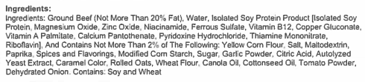

Turkey Taco Filling (Substitute)
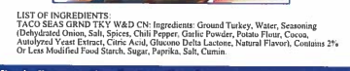

Flour Tortilla- 8”

Allergens: Wheat
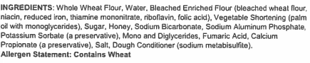

Tortilla Chips
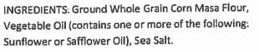

Salsa
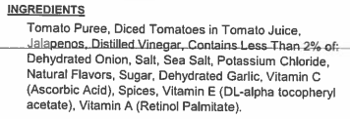

Bacon Cheeseburger
(Hamburger Patty with Turkey Bacon and American Cheese on Hamburger Bun)

Turkey Bacon
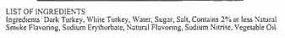

Beef Hamburger Patty

Hamburger Bun

Allergens: Wheat
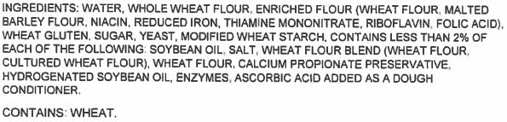

Cheese Stuffed Bread Sticks and Marinara Cup
(Cheese Filled Breadsticks served with Choice of Marinara Sauce Cup)

Cheese Stuffed Breadsticks

Allergens: Milk, Egg, Wheat, and Soy
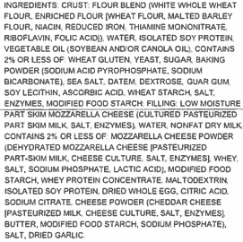

Marinara Sauce Cup
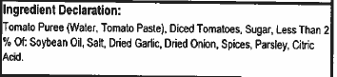

Chicken Smackers and Wheat Roll
(Breaded Chicken Pieces served with Choice of a Wheat Roll)

Chicken Smackers

Allergens: Milk, Wheat, and Soy
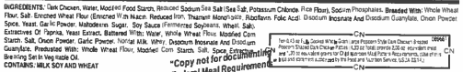

Dinner Roll

Allergens: Wheat
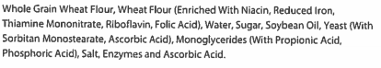

Grilled Cheese
(American and Mozzarella Grilled Cheese Sandwich)

Allergens: Wheat, Milk, Soy, and Gluten
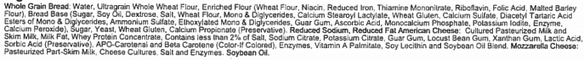

BBQ Rib Sub
(BBQ Rib Patty on French Bread Roll)

Beef Rib Pattie w/BBQ Sauce

Allergens: Milk, Soy, and Wheat
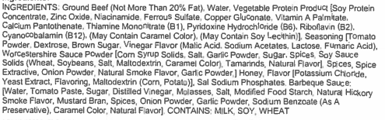

Italian Stuffed Sandwich
(Whole Grain Pepperoni Stuffed Sandwich)

Allergens: Milk, Eggs, Wheat, and Soy
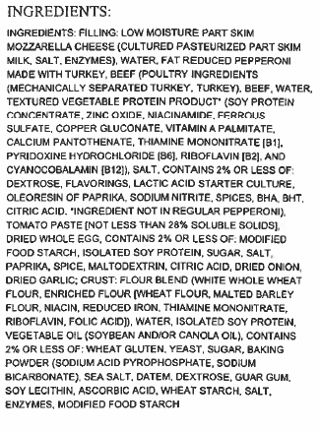

Big Daddy Pizza
(Slice of Cheese OR Pepperoni Pizza)

Big Daddy Pizza- Cheese

Allergens: Milk, Wheat, and Soy
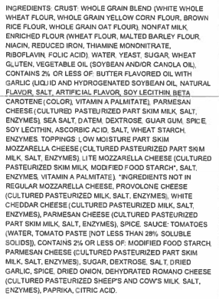

Big Daddy Pizza- Turkey Pepperoni

Allergens: Milk, Wheat, and Soy
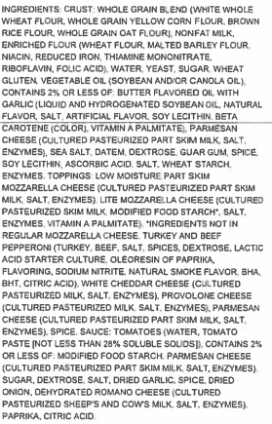

Chicken Drumstick and Wheat Roll
(Breaded and Baked Chicken Drumstick served with a Choice of Wheat Roll)

Breaded Chicken Drumstick

Allergens: Wheat
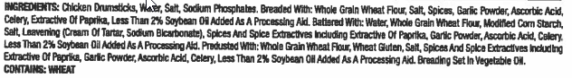

Dinner Roll

Allergens: Wheat

Crispy Chicken Sandwich
(Breaded Chicken Patty on a Hamburger Bun)

Breaded Chicken Breast Filet

Allergens: Milk and Wheat
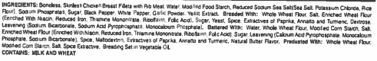

Hamburger Bun

Allergens: Wheat
Chicken Fried Steak Sandwich
(Breaded and Baked Beef Patty on Hamburger Bun)

Breaded Steak Patty

Allergens: Soy and Wheat

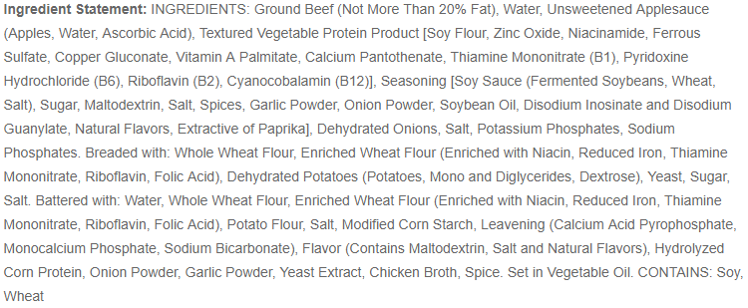

Breaded Steak Patty- Alternate

Allergens: Wheat
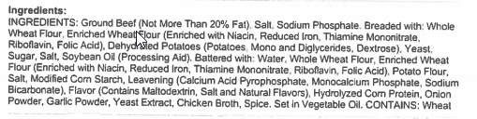

Hamburger Bun

Allergens: Wheat
Personal Pan Pizza
(Whole Grain Crust, Tomato Sauce, and Mozzarella Cheese-Pepperoni has Coin Pepperoni Pieces)

Personal Pan Pizza- Cheese

Allergens: Milk, Wheat, and Soy
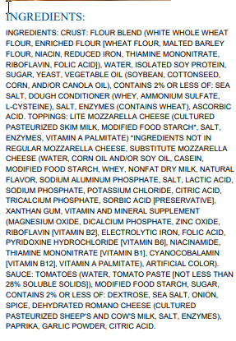

Personal Pan Pizza- Turkey and Beef Pepperoni

Allergens: Milk, Wheat, and Soy
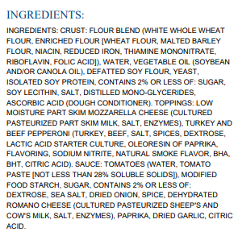

Allergens: Soy and Wheat

VEGETABLES

Crinkle Cut French Fries
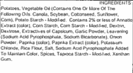

Refried Beans

Potato Rounds
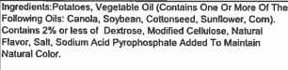

Mashed Potatoes

Allergens: Milk

County Style Gravy

Allergens: Wheat, Milk, and Soy
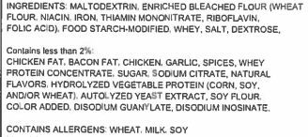
Glazed Carrots

FRUITS

Diced Peach Fruit Cup
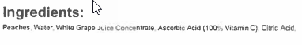

Diced Pear Fruit Cup

Fresh Apple Slices
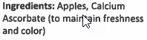

Flavored Applesauce Cup
Applesauce Cup- Strawberry Banana
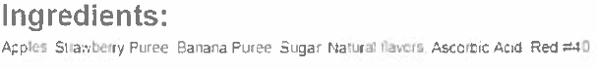
Applesauce Cup- Wild Watermelon
Applesauce Cup- Rockin’ Blue Raspberry
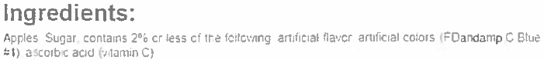

Strawberry Cup

CONDIMENTS

Mustard Packet
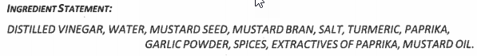

Lite Mayonnaise Packet

Allergens: Eggs
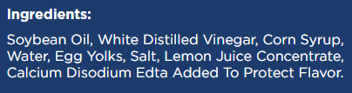

Ketchup Packet
