2018-2019 Lunch Ingredients Labels

Lunch Items- All Grades
Mini Corn Dogs
Chicken
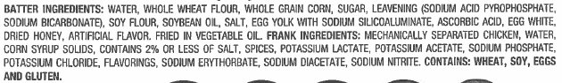

Grilled Cheese Sandwich
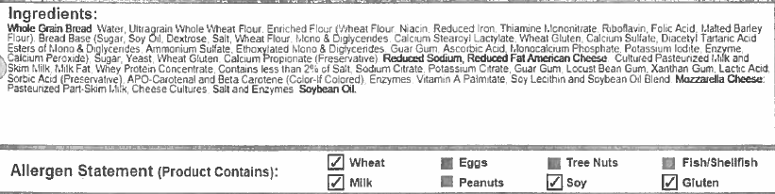
Baked Seasoned Fries
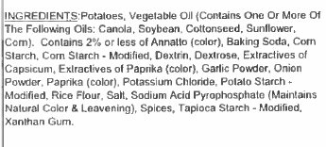
Glazed Carrots

Sliced Peaches
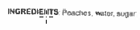
Mustard- Condiment
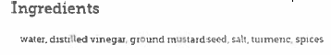
Ketchup- Condiment
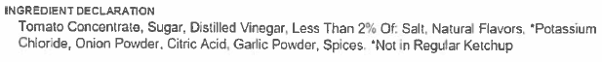
Taco Stick
Beef and Cheese Taco Stick
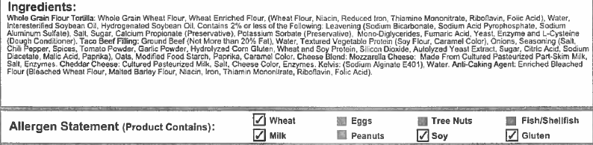
Italian Sub
French Bread
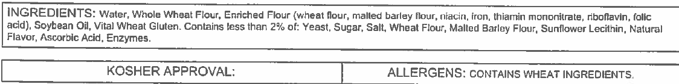
Italian Turkey Combo Deli Meat
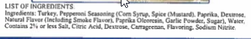

Baked Chips- Crunchy Cheese Snacks
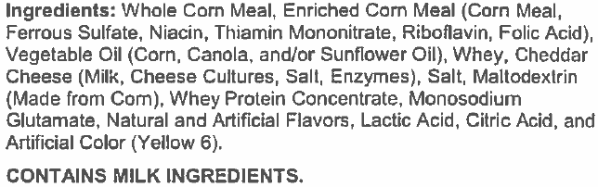

Ranchero Beans- Pinto
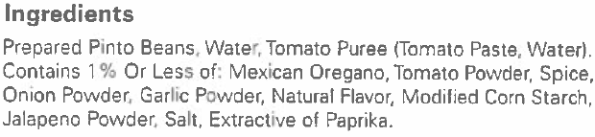
Applesauce Cup- Strawberry Banana
Applesauce Cup- Wild Watermelon
Applesauce Cup- Rockin’ Blue Raspberry
Fat Free Ranch Dressing- Condiment
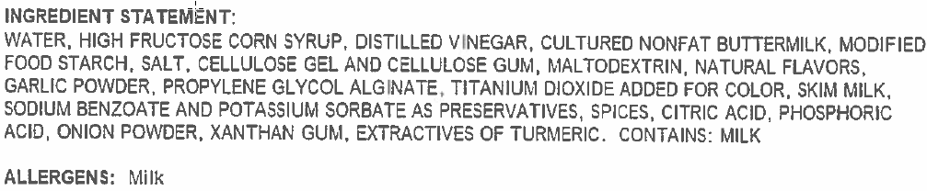

Bacon Hamburger/ Cheeseburger
100% Beef Patty
Turkey Bacon
Hamburger Bun
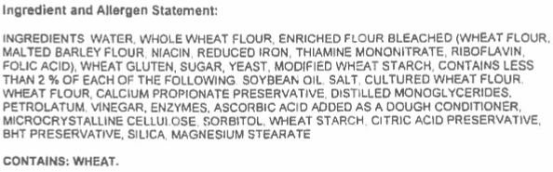

Light Mayonnaise- Condiment
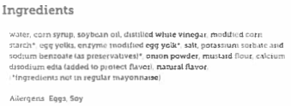

Fiesta Salad
Chicken Fajita Strips
Tortilla Chips
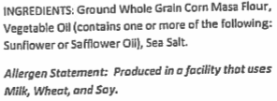
Mild Salsa
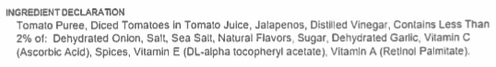
Lite Ranch Dressing Cup- Condiment
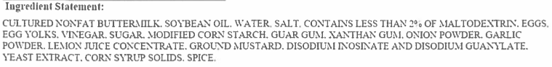

Potato Rounds
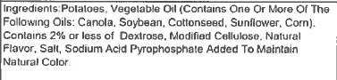

Chicken Smackers
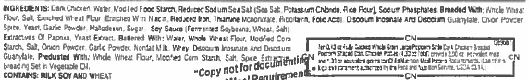
Mashed Potatoes
Country Gravy- Fat Free
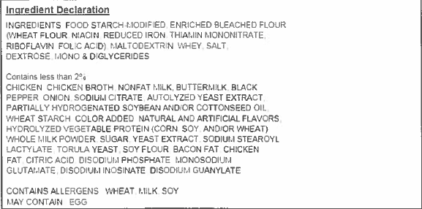
Wheat Roll
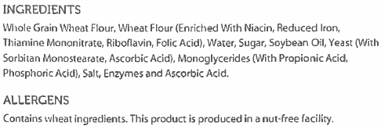
Protein Power Pack
Benefits Bar- Cocoa Chip
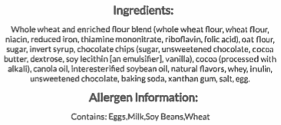
Sun-Berry Trail Mix
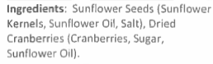
Apple Slices
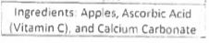

Cheese Stuffed Breadsticks
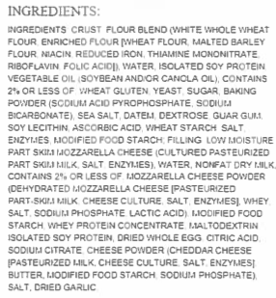
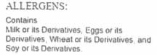

Marinara Sauce
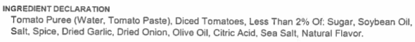

Chicken Popper Salad
Twisted Garlic Breadstick
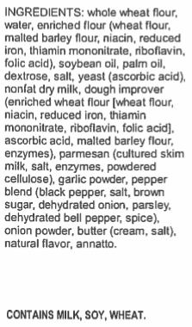

Chicken Fried Steak Sandwich
Breaded Beef Patty
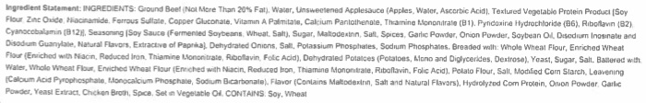
Mandarin Orange Slices
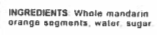
Beef Ravioli
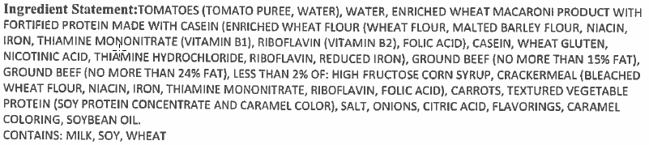

Mixed Vegetables
Pineapple Tidbits
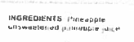
Meaty Cheesy Nachos
Taco Seasoned Turkey
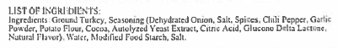
Cheddar Cheese Sauce
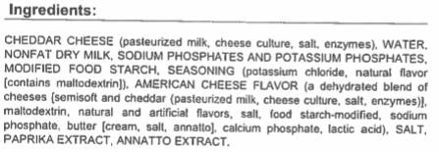

Spicy Sweet Asian Salad
Asian Glazed Breaded Chicken Chunks
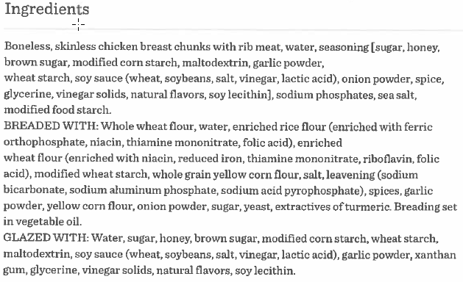
Edamame
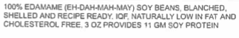

Spicy Sweet Chili Tortilla Chips
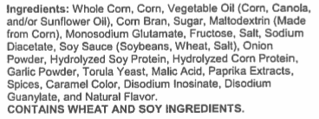
Asian Sesame Ginger Dressing
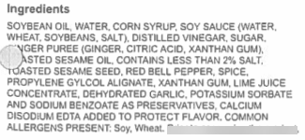

Chicken Drumstick
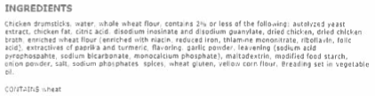

Macaroni and Cheese
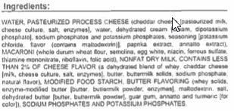

Big Daddy Pizza
Turkey Pepperoni Pizza
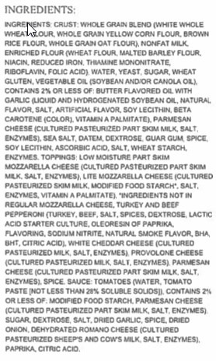

Four Cheese Pizza
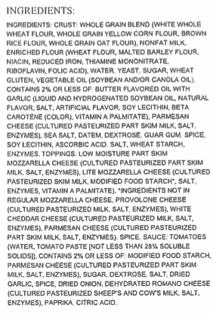

Crispy Chicken Sandwich
Breaded Chicken Breast Filet
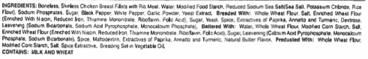

Italian Dunkers
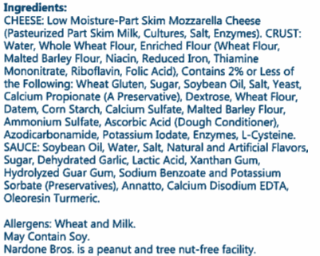
Strawberry Cup

Chicken Tenders
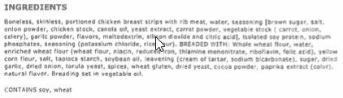
Au Gratin Potatoes
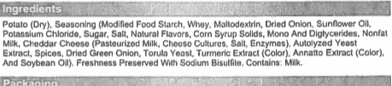

Cheeseburger Steak
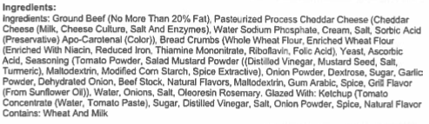

Personal Pan Pizza
Turkey and Beef Pepperoni Pizza
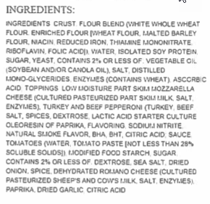

Cheese Pizza
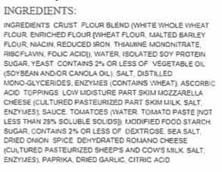

Chef Salad
Diced Turkey Ham
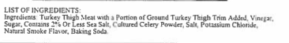

Lunch Items- 9-12 Lunch Only

Spicy Chicken Strips
Chicken Breast Spicy Tenderloins
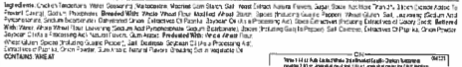

Hot Ham and cheese Sandwich
Turkey Ham
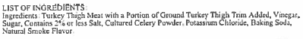

Spicy Chicken Sandwich
Hot and Spicy Chicken Breast Filet
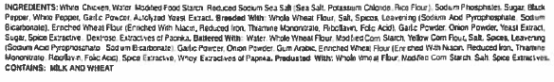

Soft Taco with Chips and Salsa
Flour Tortilla
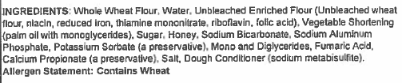

PB and J Uncrustable Meal
PB and J
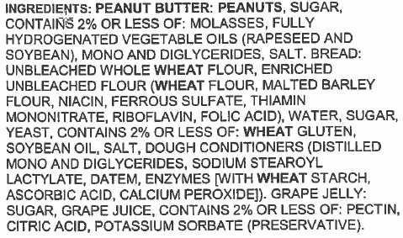

Nacho Cheese Tortilla Chips
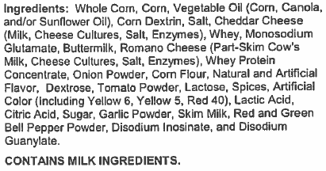
Cool Ranch Tortilla Chips
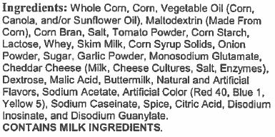
Flamas Tortilla Chips
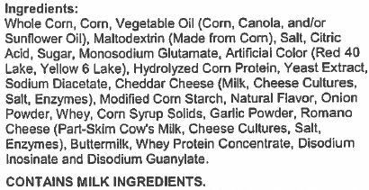

Spicy Fish Sandwich
Alaskan Pollock
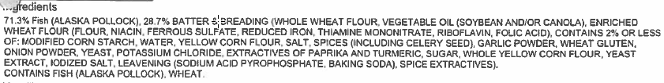

Chicken and Waffles
Breaded Chicken Breast Filet
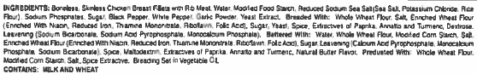Waffles
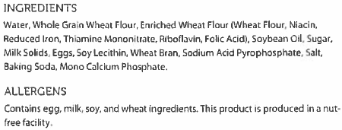

Steak Fingers
Breaded Steak finger
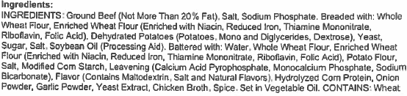

Chicken Fajita Bowl with Chips
Queso Blanca Sauce
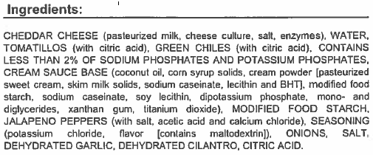
Mild Chili Powder
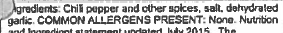

Calzone
Cheese Calzone
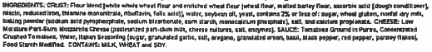

Pepperoni Calzone
