2018-2019 Breakfast Ingredient Labels

Daily Breakfast Items- All Grades
Cinnamon Toast Crunch Cereal
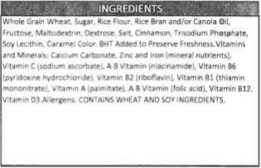
Fruity Cheerios Cereal
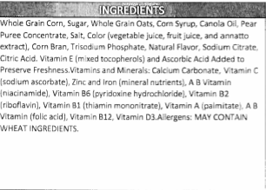
Trix 25% Less Sugar Cereal
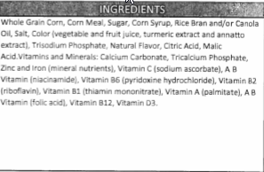

Cocoa Puffs 25% Less Sugar Cereal
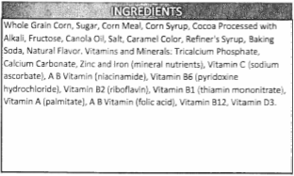
Trix Yogurt- Strawberry Banana Bash
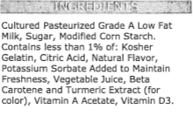
Trix Yogurt- Raspberry Rainbow
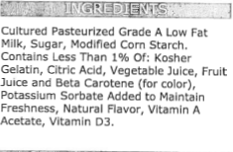

Breakfast Items- All Grades
Turkey Sausage Breakfast Pizza
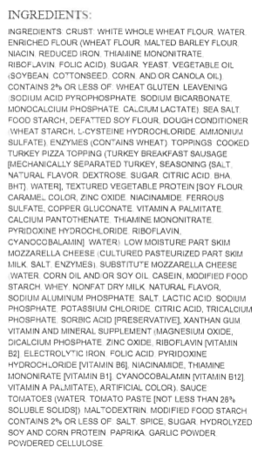
Apple Cinnamon Toast
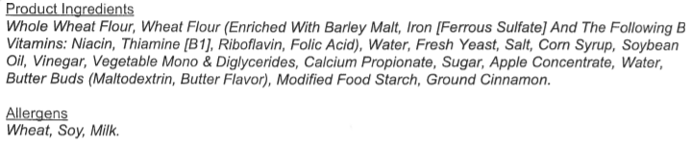
Mini Pancakes- Maple Burst’n
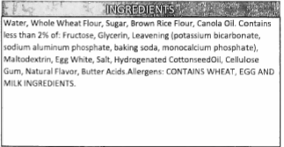
Syrup Cup
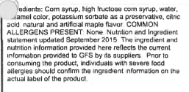
Turkey Sausage Link
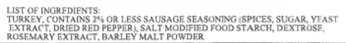
Homestyle Breaded Chicken Breakfast Patty
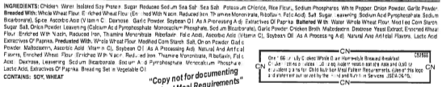
Belgian Waffle Sticks

Whole Waffle
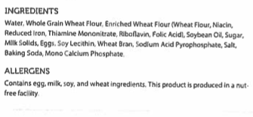
English Muffin
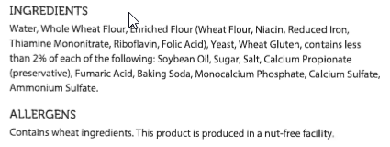
Turkey Sausage Patty
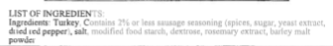
Grilled Scrambled Egg Patty
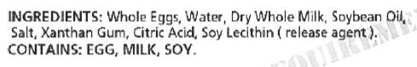
Bean and Cheese Burrito
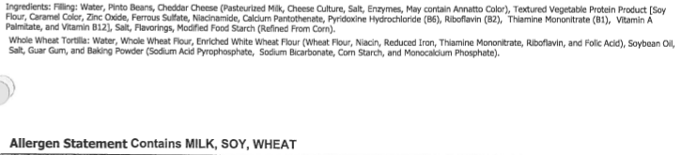
Breakfast Burger (Beef Sausage Sandwich on Hawaiian Bun)
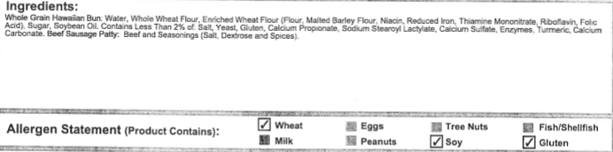
French Toast Sticks- Cinnamon Glazed
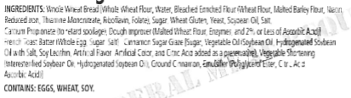
Yeast Donut Holes
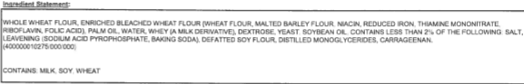
Biscuit
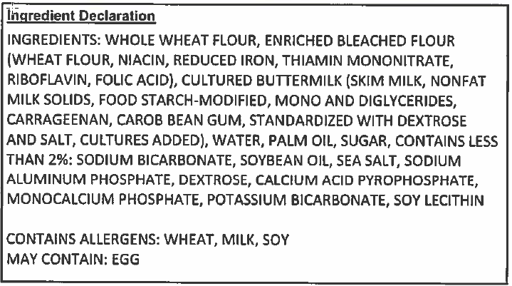

Breakfast Items- 7-12 Only
Powdered Sugar Mini Donuts
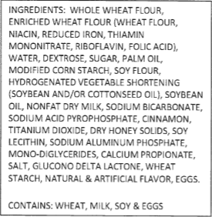
Chocolate Mini Donuts
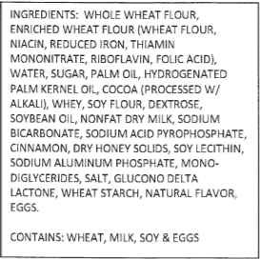

Trix Cereal Bar
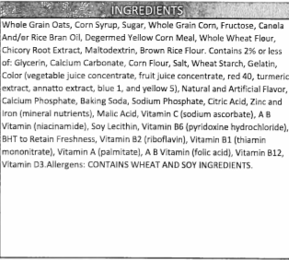
Cinnamon Toast Crunch Cereal Bar
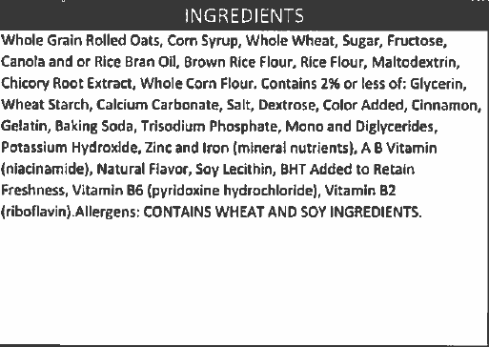

Cocoa Puffs Cereal Bar
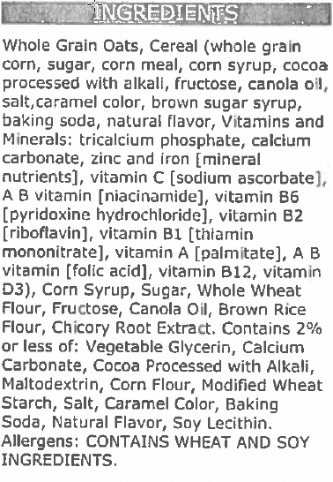
Banana Square
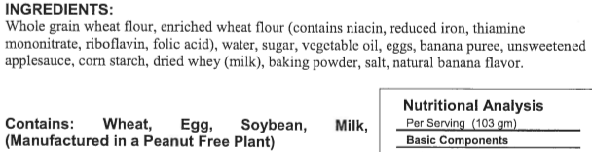

Pop Tarts- Frosted Cinnamon
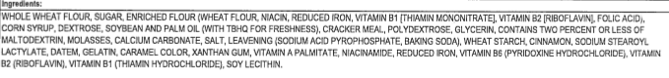
Pop Tarts- Frosted Strawberry
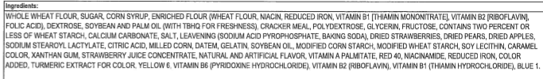

Goldfish Grahams- French Toast
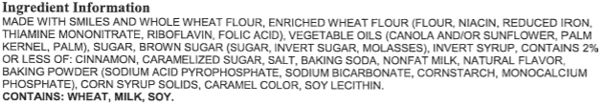
Breakfast Bun
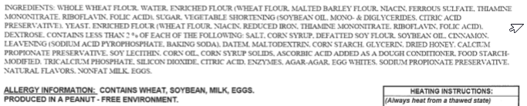

Ala Carte Items- 9-12 Only
Hash Brown Rounds
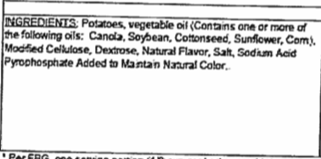

Ketchup
