2018-2019 Ala Carte Ingredient Labels

Ala Carte Items- May be Sold in K-12

Slushes
Welch’s Concord Grape
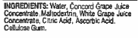
Welch’s White Grape
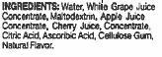
Welch’s Concord Berry
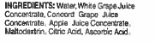

Welch’s White Grape Peach
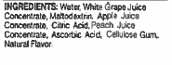
Rosati Frozen Treats- All
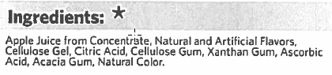
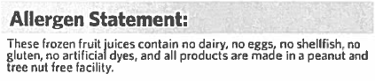
Brownie

Blastin’ Berry Hot Colors Fruit Roll-ups

Cookies
BeneFIT Sugar Cookie
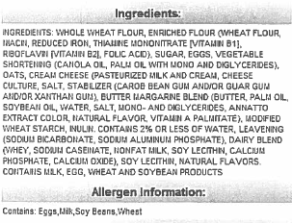
BebeFIT Candy Cookie
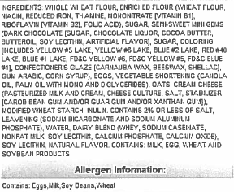
Cookie Tree Chocolate Chip Cookie
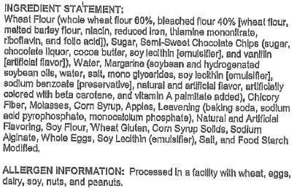

Chips
Fantastix Chili Cheese Corn and Potato Snacks
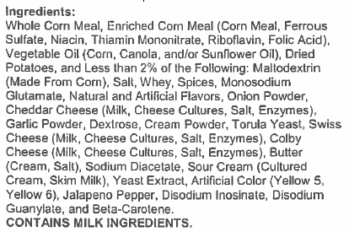
Doritos Cool Ranch
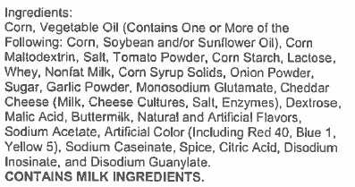
Doritos Nacho Cheese
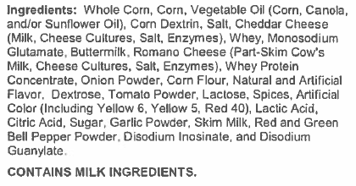
Doritos Spicy Sweet Chili
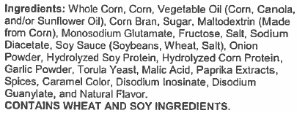

Flamin’ Hot Baked Cheetos
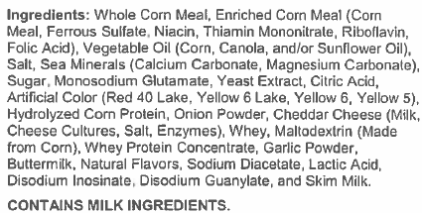
Baked Funyuns
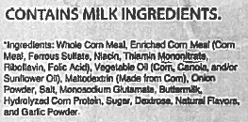
Baked Original Lay’s
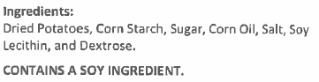
Baked Sour Cream and Onion Lay’s
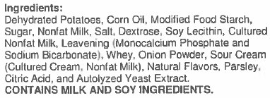
Doritos Flamas
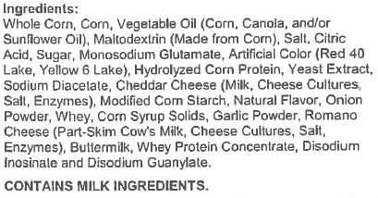

Ice Cream
Rich’s Crumbled Cookie Cone
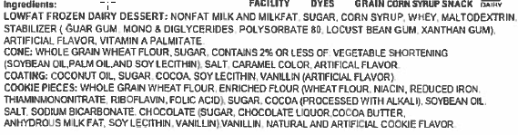
Rich’s Vanilla and Chocolate Cone
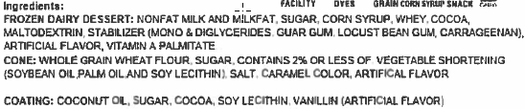
Rich’s Orange Polar Pole
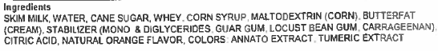
Rich’s Rainbow Polar Pole
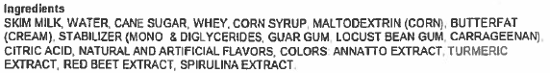
Rich’s Vanilla Sandwich
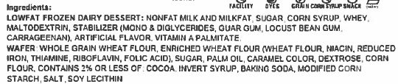
Rich’s Creamy Cotton Candy
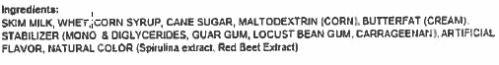
Rich’s Cherry Sour Swell
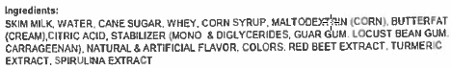

Rich’s Orange Cream Bar
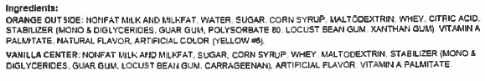
Rich’s Fudge Frenzy
Rich’s Chocolate Shortcake
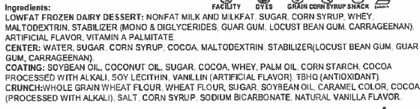
Rich’s Strawberry Shortcake
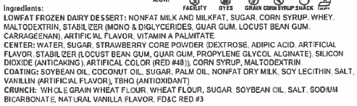
Rich’s Blue Raspberry Sour Cyclone
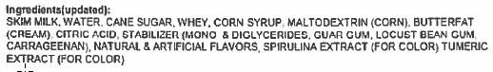
Rich’s Birthday Cake Cone
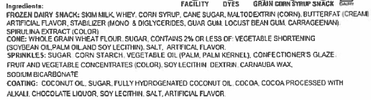
Rich’s Frozen Vanilla Cup
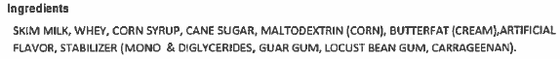
Rich’s Frozen Chocolate Cup
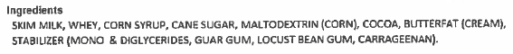
Rich’s Frozen Strawberry Cup
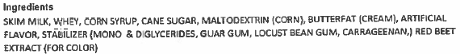
Rich’s Frozen Chocolate and Vanilla Cup

Ala Carte Items- May be Sold in 7-12
Chicken Taquito
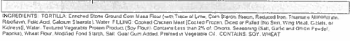
Ranchero Beef Steak Taquitos
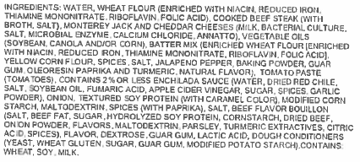
Salted Peanuts
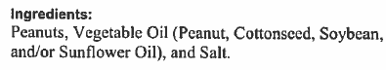
Hershey’s Fat Free Chocolate Milk
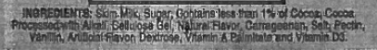

Chicken Corn Dogs
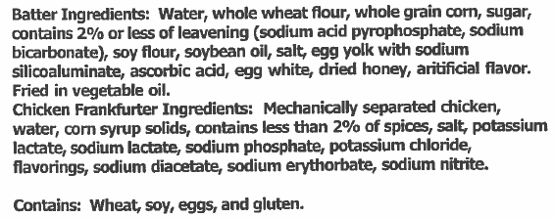
Pork and Vegetable Egg Roll
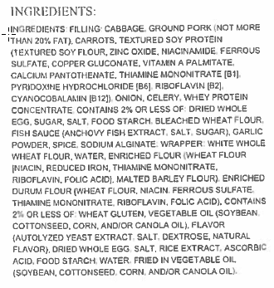
Green Apple Snapple
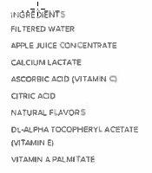

Fruit Punch Snapple
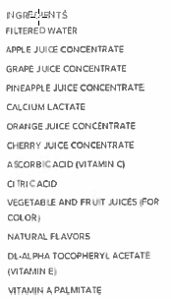
Apple Switch
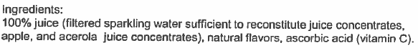
Black Cherry Switch
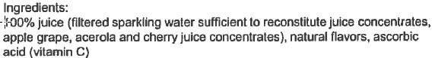
Fruit Punch Switch
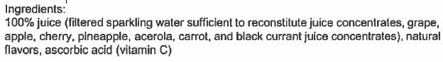
Grape Switch
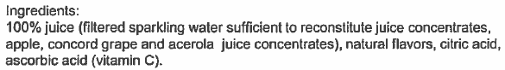
Kiwi Berry Switch
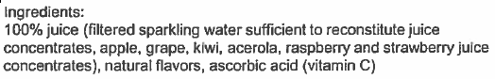
Tropical Pineapple Switch
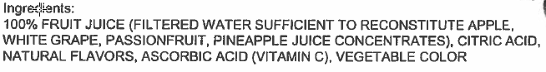
Orange Tangerine Switch
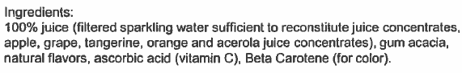
Watermelon Strawberry Switch
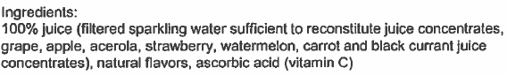
Lemon Lime Switch
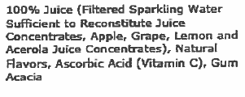
Hard Core Apple Switch
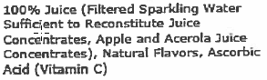
Bosco Cheese Stick
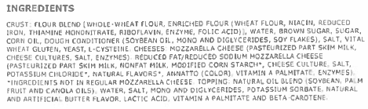
Bubbly Sparkling Water- All Flavors

Ala Carte Items- May be Sold in 9-12
Watermelon Propel
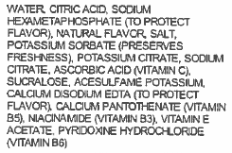

Strawberry Kiwi Propel
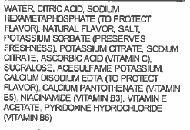
Clear Mixed Berry G2
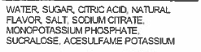
Fruit Punch G2
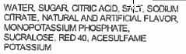
Glacier Freeze G2
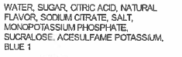
Orange G2
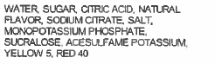
Grape G2
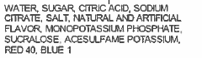
JB’s Decaf Not So Sweet Tea
Red Diamond Sugar Free Tea
JB’s Decaf Lemon Tea
JB’s Decaf Mango Tea

